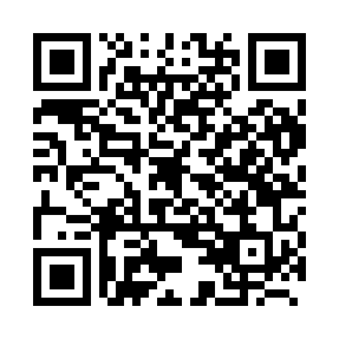
Prayer times for Fortem, Belgium
Wed 1 May 2024 - Fri 31 May 2024
High Latitude Method: Angle Based Rule
Prayer Calculation Method: Muslim World League
Asar Calculation Method: Shafi

Date | Day | Fajr | Sunrise | Dhuhr | Asr | Maghrib | Isha
1 | Wed | 3:55 | 6:22 | 1:46 | 5:49 | 9:11 | 11:27
2 | Thu | 3:52 | 6:20 | 1:46 | 5:49 | 9:13 | 11:30
3 | Fri | 3:48 | 6:18 | 1:46 | 5:50 | 9:15 | 11:33
4 | Sat | 3:45 | 6:16 | 1:46 | 5:51 | 9:16 | 11:36
5 | Sun | 3:41 | 6:15 | 1:46 | 5:51 | 9:18 | 11:39
6 | Mon | 3:38 | 6:13 | 1:46 | 5:52 | 9:19 | 11:43
7 | Tue | 3:34 | 6:11 | 1:46 | 5:52 | 9:21 | 11:46
8 | Wed | 3:31 | 6:09 | 1:46 | 5:53 | 9:23 | 11:49
9 | Thu | 3:31 | 6:08 | 1:46 | 5:54 | 9:24 | 11:52
10 | Fri | 3:30 | 6:06 | 1:45 | 5:54 | 9:26 | 11:53
11 | Sat | 3:29 | 6:05 | 1:45 | 5:55 | 9:27 | 11:54
12 | Sun | 3:29 | 6:03 | 1:45 | 5:55 | 9:29 | 11:54
13 | Mon | 3:28 | 6:02 | 1:45 | 5:56 | 9:30 | 11:55
14 | Tue | 3:28 | 6:00 | 1:45 | 5:57 | 9:32 | 11:56
15 | Wed | 3:27 | 5:59 | 1:45 | 5:57 | 9:33 | 11:56
16 | Thu | 3:26 | 5:57 | 1:45 | 5:58 | 9:35 | 11:57
17 | Fri | 3:26 | 5:56 | 1:46 | 5:58 | 9:36 | 11:58
18 | Sat | 3:25 | 5:54 | 1:46 | 5:59 | 9:37 | 11:58
19 | Sun | 3:25 | 5:53 | 1:46 | 5:59 | 9:39 | 11:59
20 | Mon | 3:24 | 5:52 | 1:46 | 6:00 | 9:40 | 11:59
21 | Tue | 3:24 | 5:51 | 1:46 | 6:01 | 9:42 | 12:00
22 | Wed | 3:23 | 5:49 | 1:46 | 6:01 | 9:43 | 12:01
23 | Thu | 3:23 | 5:48 | 1:46 | 6:02 | 9:44 | 12:01
24 | Fri | 3:23 | 5:47 | 1:46 | 6:02 | 9:45 | 12:02
25 | Sat | 3:22 | 5:46 | 1:46 | 6:03 | 9:47 | 12:03
26 | Sun | 3:22 | 5:45 | 1:46 | 6:03 | 9:48 | 12:03
27 | Mon | 3:22 | 5:44 | 1:46 | 6:04 | 9:49 | 12:04
28 | Tue | 3:21 | 5:43 | 1:46 | 6:04 | 9:50 | 12:04
29 | Wed | 3:21 | 5:42 | 1:47 | 6:05 | 9:52 | 12:05
30 | Thu | 3:21 | 5:41 | 1:47 | 6:05 | 9:53 | 12:05
31 | Fri | 3:20 | 5:40 | 1:47 | 6:06 | 9:54 | 12:06
Prayer times provided by https://www.salahtimes.com

