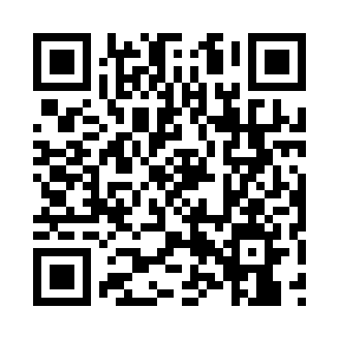

**Prayer times for Franiere, Belgium**

**Sun 1 Sep 2024 - Mon 30 Sep 2024**

**High Latitude Method: Angle Based Rule**

**Prayer Calculation Method: Muslim World League**

**Asar Calculation Method: Shafi**

|  |  |  |  |  |  |  |  |
| --- | --- | --- | --- | --- | --- | --- | --- |
| **Date** | **Day** | **Fajr** | **Sunrise** | **Dhuhr** | **Asr** | **Maghrib** | **Isha** |
| 1 | Sun | 4:55 | 6:56 | 1:41 | 5:24 | 8:25 | 10:17 |
| 2 | Mon | 4:57 | 6:58 | 1:41 | 5:22 | 8:23 | 10:15 |
| 3 | Tue | 4:59 | 6:59 | 1:40 | 5:21 | 8:21 | 10:12 |
| 4 | Wed | 5:02 | 7:01 | 1:40 | 5:19 | 8:18 | 10:09 |
| 5 | Thu | 5:04 | 7:02 | 1:40 | 5:18 | 8:16 | 10:07 |
| 6 | Fri | 5:06 | 7:04 | 1:39 | 5:17 | 8:14 | 10:04 |
| 7 | Sat | 5:08 | 7:05 | 1:39 | 5:15 | 8:12 | 10:01 |
| 8 | Sun | 5:10 | 7:07 | 1:39 | 5:14 | 8:10 | 9:58 |
| 9 | Mon | 5:12 | 7:08 | 1:38 | 5:12 | 8:07 | 9:56 |
| 10 | Tue | 5:14 | 7:10 | 1:38 | 5:11 | 8:05 | 9:53 |
| 11 | Wed | 5:16 | 7:11 | 1:38 | 5:09 | 8:03 | 9:50 |
| 12 | Thu | 5:18 | 7:13 | 1:37 | 5:08 | 8:01 | 9:48 |
| 13 | Fri | 5:20 | 7:14 | 1:37 | 5:06 | 7:58 | 9:45 |
| 14 | Sat | 5:22 | 7:16 | 1:36 | 5:05 | 7:56 | 9:43 |
| 15 | Sun | 5:24 | 7:17 | 1:36 | 5:03 | 7:54 | 9:40 |
| 16 | Mon | 5:26 | 7:19 | 1:36 | 5:02 | 7:52 | 9:37 |
| 17 | Tue | 5:28 | 7:20 | 1:35 | 5:00 | 7:50 | 9:35 |
| 18 | Wed | 5:30 | 7:22 | 1:35 | 4:59 | 7:47 | 9:32 |
| 19 | Thu | 5:31 | 7:23 | 1:35 | 4:57 | 7:45 | 9:30 |
| 20 | Fri | 5:33 | 7:25 | 1:34 | 4:55 | 7:43 | 9:27 |
| 21 | Sat | 5:35 | 7:26 | 1:34 | 4:54 | 7:41 | 9:25 |
| 22 | Sun | 5:37 | 7:28 | 1:34 | 4:52 | 7:38 | 9:22 |
| 23 | Mon | 5:39 | 7:29 | 1:33 | 4:51 | 7:36 | 9:20 |
| 24 | Tue | 5:40 | 7:31 | 1:33 | 4:49 | 7:34 | 9:17 |
| 25 | Wed | 5:42 | 7:33 | 1:33 | 4:47 | 7:32 | 9:15 |
| 26 | Thu | 5:44 | 7:34 | 1:32 | 4:46 | 7:29 | 9:13 |
| 27 | Fri | 5:46 | 7:36 | 1:32 | 4:44 | 7:27 | 9:10 |
| 28 | Sat | 5:48 | 7:37 | 1:32 | 4:43 | 7:25 | 9:08 |
| 29 | Sun | 5:49 | 7:39 | 1:31 | 4:41 | 7:23 | 9:06 |
| 30 | Mon | 5:51 | 7:40 | 1:31 | 4:39 | 7:21 | 9:03 |

**Prayer times provided by https://www.salahtimes.com**