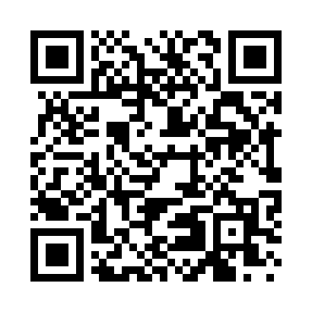
Prayer times for Fort Elfsborg, New Jersey, USA
Mon 1 Jul 2024 - Wed 31 Jul 2024
High Latitude Method: Angle Based Rule
Prayer Calculation Method: Islamic Society of North America
Asar Calculation Method: Shafi

Date | Day | Fajr | Sunrise | Dhuhr | Asr | Maghrib | Isha
1 | Mon | 4:03 | 5:39 | 1:06 | 5:04 | 8:33 | 10:09
2 | Tue | 4:04 | 5:39 | 1:06 | 5:04 | 8:33 | 10:09
3 | Wed | 4:04 | 5:40 | 1:07 | 5:04 | 8:33 | 10:08
4 | Thu | 4:05 | 5:40 | 1:07 | 5:04 | 8:33 | 10:08
5 | Fri | 4:06 | 5:41 | 1:07 | 5:04 | 8:33 | 10:07
6 | Sat | 4:07 | 5:42 | 1:07 | 5:04 | 8:32 | 10:07
7 | Sun | 4:08 | 5:42 | 1:07 | 5:04 | 8:32 | 10:06
8 | Mon | 4:09 | 5:43 | 1:07 | 5:04 | 8:32 | 10:06
9 | Tue | 4:09 | 5:43 | 1:07 | 5:04 | 8:31 | 10:05
10 | Wed | 4:10 | 5:44 | 1:08 | 5:04 | 8:31 | 10:04
11 | Thu | 4:11 | 5:45 | 1:08 | 5:04 | 8:30 | 10:04
12 | Fri | 4:12 | 5:45 | 1:08 | 5:04 | 8:30 | 10:03
13 | Sat | 4:13 | 5:46 | 1:08 | 5:04 | 8:29 | 10:02
14 | Sun | 4:14 | 5:47 | 1:08 | 5:04 | 8:29 | 10:01
15 | Mon | 4:15 | 5:48 | 1:08 | 5:04 | 8:28 | 10:00
16 | Tue | 4:17 | 5:48 | 1:08 | 5:04 | 8:28 | 9:59
17 | Wed | 4:18 | 5:49 | 1:08 | 5:04 | 8:27 | 9:59
18 | Thu | 4:19 | 5:50 | 1:08 | 5:04 | 8:26 | 9:58
19 | Fri | 4:20 | 5:51 | 1:08 | 5:04 | 8:26 | 9:57
20 | Sat | 4:21 | 5:52 | 1:09 | 5:04 | 8:25 | 9:55
21 | Sun | 4:22 | 5:52 | 1:09 | 5:04 | 8:24 | 9:54
22 | Mon | 4:23 | 5:53 | 1:09 | 5:04 | 8:23 | 9:53
23 | Tue | 4:25 | 5:54 | 1:09 | 5:03 | 8:23 | 9:52
24 | Wed | 4:26 | 5:55 | 1:09 | 5:03 | 8:22 | 9:51
25 | Thu | 4:27 | 5:56 | 1:09 | 5:03 | 8:21 | 9:50
26 | Fri | 4:28 | 5:57 | 1:09 | 5:03 | 8:20 | 9:48
27 | Sat | 4:29 | 5:58 | 1:09 | 5:03 | 8:19 | 9:47
28 | Sun | 4:31 | 5:59 | 1:09 | 5:02 | 8:18 | 9:46
29 | Mon | 4:32 | 5:59 | 1:09 | 5:02 | 8:17 | 9:45
30 | Tue | 4:33 | 6:00 | 1:09 | 5:02 | 8:16 | 9:43
31 | Wed | 4:34 | 6:01 | 1:08 | 5:01 | 8:15 | 9:42
Prayer times provided by https://www.salahtimes.com

