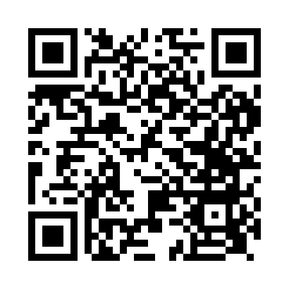

**Prayer times for Noss Island, UK**

**Wed 1 Jan 2025 - Fri 31 Jan 2025**

**High Latitude Method: Angle Based Rule**

**Prayer Calculation Method: Islamic Society of North America**

**Asar Calculation Method: Hanafi**

|  |  |  |  |  |  |  |  |
| --- | --- | --- | --- | --- | --- | --- | --- |
| **Date** | **Day** | **Fajr** | **Sunrise** | **Dhuhr** | **Asr** | **Maghrib** | **Isha** |
| 1 | Wed | 6:48 | 9:08 | 12:08 | 1:21 | 3:08 | 5:28 |
| 2 | Thu | 6:48 | 9:07 | 12:08 | 1:22 | 3:10 | 5:29 |
| 3 | Fri | 6:47 | 9:06 | 12:09 | 1:24 | 3:12 | 5:30 |
| 4 | Sat | 6:47 | 9:06 | 12:09 | 1:25 | 3:13 | 5:32 |
| 5 | Sun | 6:47 | 9:05 | 12:10 | 1:27 | 3:15 | 5:33 |
| 6 | Mon | 6:46 | 9:04 | 12:10 | 1:28 | 3:17 | 5:34 |
| 7 | Tue | 6:46 | 9:03 | 12:10 | 1:30 | 3:19 | 5:36 |
| 8 | Wed | 6:45 | 9:02 | 12:11 | 1:31 | 3:21 | 5:37 |
| 9 | Thu | 6:45 | 9:01 | 12:11 | 1:33 | 3:22 | 5:39 |
| 10 | Fri | 6:44 | 9:00 | 12:12 | 1:35 | 3:25 | 5:40 |
| 11 | Sat | 6:43 | 8:58 | 12:12 | 1:37 | 3:27 | 5:42 |
| 12 | Sun | 6:42 | 8:57 | 12:12 | 1:38 | 3:29 | 5:43 |
| 13 | Mon | 6:42 | 8:56 | 12:13 | 1:40 | 3:31 | 5:45 |
| 14 | Tue | 6:41 | 8:54 | 12:13 | 1:42 | 3:33 | 5:46 |
| 15 | Wed | 6:40 | 8:53 | 12:14 | 1:44 | 3:35 | 5:48 |
| 16 | Thu | 6:39 | 8:51 | 12:14 | 1:46 | 3:38 | 5:50 |
| 17 | Fri | 6:38 | 8:49 | 12:14 | 1:48 | 3:40 | 5:52 |
| 18 | Sat | 6:36 | 8:48 | 12:15 | 1:50 | 3:43 | 5:53 |
| 19 | Sun | 6:35 | 8:46 | 12:15 | 1:52 | 3:45 | 5:55 |
| 20 | Mon | 6:34 | 8:44 | 12:15 | 1:55 | 3:47 | 5:57 |
| 21 | Tue | 6:33 | 8:42 | 12:15 | 1:57 | 3:50 | 5:59 |
| 22 | Wed | 6:31 | 8:40 | 12:16 | 1:59 | 3:52 | 6:01 |
| 23 | Thu | 6:30 | 8:38 | 12:16 | 2:01 | 3:55 | 6:03 |
| 24 | Fri | 6:29 | 8:36 | 12:16 | 2:03 | 3:57 | 6:05 |
| 25 | Sat | 6:27 | 8:34 | 12:16 | 2:06 | 4:00 | 6:07 |
| 26 | Sun | 6:26 | 8:32 | 12:17 | 2:08 | 4:03 | 6:09 |
| 27 | Mon | 6:24 | 8:30 | 12:17 | 2:10 | 4:05 | 6:11 |
| 28 | Tue | 6:22 | 8:28 | 12:17 | 2:13 | 4:08 | 6:13 |
| 29 | Wed | 6:21 | 8:25 | 12:17 | 2:15 | 4:10 | 6:15 |
| 30 | Thu | 6:19 | 8:23 | 12:17 | 2:17 | 4:13 | 6:17 |
| 31 | Fri | 6:17 | 8:21 | 12:18 | 2:20 | 4:16 | 6:19 |

**Prayer times provided by https://www.salahtimes.com**