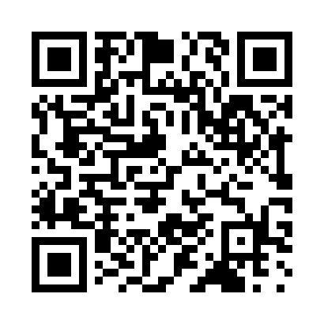

**Prayer times for Abango, Spain**

**Sun 1 Sep 2024 - Mon 30 Sep 2024**

**High Latitude Method: Angle Based Rule**

**Prayer Calculation Method: Muslim World League**

**Asar Calculation Method: Hanafi**

|  |  |  |  |  |  |  |  |
| --- | --- | --- | --- | --- | --- | --- | --- |
| **Date** | **Day** | **Fajr** | **Sunrise** | **Dhuhr** | **Asr** | **Maghrib** | **Isha** |
| 1 | Sun | 6:08 | 7:50 | 2:25 | 7:04 | 9:00 | 10:35 |
| 2 | Mon | 6:10 | 7:51 | 2:25 | 7:02 | 8:58 | 10:33 |
| 3 | Tue | 6:11 | 7:52 | 2:25 | 7:01 | 8:56 | 10:31 |
| 4 | Wed | 6:13 | 7:53 | 2:24 | 6:59 | 8:54 | 10:28 |
| 5 | Thu | 6:14 | 7:54 | 2:24 | 6:58 | 8:53 | 10:26 |
| 6 | Fri | 6:16 | 7:55 | 2:24 | 6:57 | 8:51 | 10:24 |
| 7 | Sat | 6:17 | 7:56 | 2:23 | 6:55 | 8:49 | 10:22 |
| 8 | Sun | 6:18 | 7:58 | 2:23 | 6:54 | 8:47 | 10:20 |
| 9 | Mon | 6:20 | 7:59 | 2:22 | 6:52 | 8:46 | 10:18 |
| 10 | Tue | 6:21 | 8:00 | 2:22 | 6:51 | 8:44 | 10:16 |
| 11 | Wed | 6:23 | 8:01 | 2:22 | 6:49 | 8:42 | 10:14 |
| 12 | Thu | 6:24 | 8:02 | 2:21 | 6:48 | 8:40 | 10:12 |
| 13 | Fri | 6:25 | 8:03 | 2:21 | 6:47 | 8:38 | 10:10 |
| 14 | Sat | 6:27 | 8:04 | 2:21 | 6:45 | 8:37 | 10:08 |
| 15 | Sun | 6:28 | 8:05 | 2:20 | 6:44 | 8:35 | 10:06 |
| 16 | Mon | 6:29 | 8:06 | 2:20 | 6:42 | 8:33 | 10:04 |
| 17 | Tue | 6:31 | 8:07 | 2:20 | 6:41 | 8:31 | 10:02 |
| 18 | Wed | 6:32 | 8:09 | 2:19 | 6:39 | 8:29 | 10:00 |
| 19 | Thu | 6:33 | 8:10 | 2:19 | 6:38 | 8:27 | 9:58 |
| 20 | Fri | 6:35 | 8:11 | 2:19 | 6:36 | 8:26 | 9:56 |
| 21 | Sat | 6:36 | 8:12 | 2:18 | 6:34 | 8:24 | 9:54 |
| 22 | Sun | 6:37 | 8:13 | 2:18 | 6:33 | 8:22 | 9:52 |
| 23 | Mon | 6:38 | 8:14 | 2:18 | 6:31 | 8:20 | 9:50 |
| 24 | Tue | 6:40 | 8:15 | 2:17 | 6:30 | 8:18 | 9:48 |
| 25 | Wed | 6:41 | 8:16 | 2:17 | 6:28 | 8:17 | 9:46 |
| 26 | Thu | 6:42 | 8:17 | 2:16 | 6:27 | 8:15 | 9:44 |
| 27 | Fri | 6:43 | 8:19 | 2:16 | 6:25 | 8:13 | 9:42 |
| 28 | Sat | 6:45 | 8:20 | 2:16 | 6:24 | 8:11 | 9:41 |
| 29 | Sun | 6:46 | 8:21 | 2:15 | 6:22 | 8:09 | 9:39 |
| 30 | Mon | 6:47 | 8:22 | 2:15 | 6:20 | 8:08 | 9:37 |

**Prayer times provided by https://www.salahtimes.com**