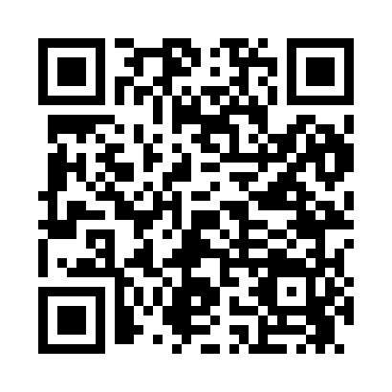
Prayer times for Baring, Maine, USA
Mon 1 Jul 2024 - Wed 31 Jul 2024
High Latitude Method: Angle Based Rule
Prayer Calculation Method: Islamic Society of North America
Asar Calculation Method: Shafi

Date | Day | Fajr | Sunrise | Dhuhr | Asr | Maghrib | Isha
1 | Mon | 2:50 | 4:46 | 12:33 | 4:42 | 8:20 | 10:16
2 | Tue | 2:51 | 4:47 | 12:33 | 4:42 | 8:20 | 10:15
3 | Wed | 2:52 | 4:47 | 12:34 | 4:42 | 8:20 | 10:15
4 | Thu | 2:53 | 4:48 | 12:34 | 4:42 | 8:19 | 10:14
5 | Fri | 2:54 | 4:49 | 12:34 | 4:43 | 8:19 | 10:13
6 | Sat | 2:55 | 4:50 | 12:34 | 4:43 | 8:19 | 10:12
7 | Sun | 2:57 | 4:50 | 12:34 | 4:43 | 8:18 | 10:12
8 | Mon | 2:58 | 4:51 | 12:34 | 4:43 | 8:18 | 10:11
9 | Tue | 2:59 | 4:52 | 12:35 | 4:42 | 8:17 | 10:10
10 | Wed | 3:00 | 4:53 | 12:35 | 4:42 | 8:17 | 10:09
11 | Thu | 3:02 | 4:53 | 12:35 | 4:42 | 8:16 | 10:07
12 | Fri | 3:03 | 4:54 | 12:35 | 4:42 | 8:15 | 10:06
13 | Sat | 3:04 | 4:55 | 12:35 | 4:42 | 8:15 | 10:05
14 | Sun | 3:06 | 4:56 | 12:35 | 4:42 | 8:14 | 10:04
15 | Mon | 3:07 | 4:57 | 12:35 | 4:42 | 8:13 | 10:03
16 | Tue | 3:09 | 4:58 | 12:35 | 4:42 | 8:12 | 10:01
17 | Wed | 3:10 | 4:59 | 12:36 | 4:42 | 8:12 | 10:00
18 | Thu | 3:12 | 5:00 | 12:36 | 4:41 | 8:11 | 9:59
19 | Fri | 3:13 | 5:01 | 12:36 | 4:41 | 8:10 | 9:57
20 | Sat | 3:15 | 5:02 | 12:36 | 4:41 | 8:09 | 9:56
21 | Sun | 3:17 | 5:03 | 12:36 | 4:41 | 8:08 | 9:54
22 | Mon | 3:18 | 5:04 | 12:36 | 4:40 | 8:07 | 9:52
23 | Tue | 3:20 | 5:05 | 12:36 | 4:40 | 8:06 | 9:51
24 | Wed | 3:22 | 5:06 | 12:36 | 4:40 | 8:05 | 9:49
25 | Thu | 3:23 | 5:07 | 12:36 | 4:39 | 8:04 | 9:48
26 | Fri | 3:25 | 5:08 | 12:36 | 4:39 | 8:03 | 9:46
27 | Sat | 3:27 | 5:09 | 12:36 | 4:39 | 8:02 | 9:44
28 | Sun | 3:28 | 5:10 | 12:36 | 4:38 | 8:01 | 9:42
29 | Mon | 3:30 | 5:12 | 12:36 | 4:38 | 7:59 | 9:41
30 | Tue | 3:32 | 5:13 | 12:36 | 4:37 | 7:58 | 9:39
31 | Wed | 3:33 | 5:14 | 12:36 | 4:37 | 7:57 | 9:37
Prayer times provided by https://www.salahtimes.com

