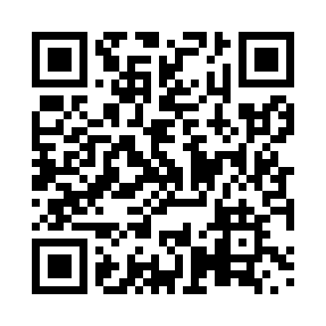

**Prayer times for Rush Lake, Saskatchewan, Canada**

**Wed 1 Jan 2025 - Fri 31 Jan 2025**

**High Latitude Method: Angle Based Rule**

**Prayer Calculation Method: Islamic Society of North America**

**Asar Calculation Method: Hanafi**

|  |  |  |  |  |  |  |  |
| --- | --- | --- | --- | --- | --- | --- | --- |
| **Date** | **Day** | **Fajr** | **Sunrise** | **Dhuhr** | **Asr** | **Maghrib** | **Isha** |
| 1 | Wed | 7:30 | 9:10 | 1:13 | 3:31 | 5:17 | 6:58 |
| 2 | Thu | 7:30 | 9:10 | 1:14 | 3:32 | 5:18 | 6:58 |
| 3 | Fri | 7:30 | 9:10 | 1:14 | 3:33 | 5:19 | 6:59 |
| 4 | Sat | 7:30 | 9:09 | 1:15 | 3:34 | 5:21 | 7:00 |
| 5 | Sun | 7:29 | 9:09 | 1:15 | 3:36 | 5:22 | 7:01 |
| 6 | Mon | 7:29 | 9:09 | 1:16 | 3:37 | 5:23 | 7:02 |
| 7 | Tue | 7:29 | 9:08 | 1:16 | 3:38 | 5:24 | 7:04 |
| 8 | Wed | 7:29 | 9:08 | 1:17 | 3:39 | 5:26 | 7:05 |
| 9 | Thu | 7:29 | 9:07 | 1:17 | 3:40 | 5:27 | 7:06 |
| 10 | Fri | 7:28 | 9:07 | 1:17 | 3:42 | 5:28 | 7:07 |
| 11 | Sat | 7:28 | 9:06 | 1:18 | 3:43 | 5:30 | 7:08 |
| 12 | Sun | 7:27 | 9:06 | 1:18 | 3:44 | 5:31 | 7:09 |
| 13 | Mon | 7:27 | 9:05 | 1:18 | 3:46 | 5:33 | 7:11 |
| 14 | Tue | 7:26 | 9:04 | 1:19 | 3:47 | 5:34 | 7:12 |
| 15 | Wed | 7:26 | 9:04 | 1:19 | 3:49 | 5:35 | 7:13 |
| 16 | Thu | 7:25 | 9:03 | 1:20 | 3:50 | 5:37 | 7:14 |
| 17 | Fri | 7:25 | 9:02 | 1:20 | 3:52 | 5:39 | 7:16 |
| 18 | Sat | 7:24 | 9:01 | 1:20 | 3:53 | 5:40 | 7:17 |
| 19 | Sun | 7:23 | 9:00 | 1:20 | 3:55 | 5:42 | 7:18 |
| 20 | Mon | 7:23 | 8:59 | 1:21 | 3:56 | 5:43 | 7:20 |
| 21 | Tue | 7:22 | 8:58 | 1:21 | 3:58 | 5:45 | 7:21 |
| 22 | Wed | 7:21 | 8:57 | 1:21 | 3:59 | 5:47 | 7:22 |
| 23 | Thu | 7:20 | 8:56 | 1:22 | 4:01 | 5:48 | 7:24 |
| 24 | Fri | 7:19 | 8:54 | 1:22 | 4:02 | 5:50 | 7:25 |
| 25 | Sat | 7:18 | 8:53 | 1:22 | 4:04 | 5:52 | 7:27 |
| 26 | Sun | 7:17 | 8:52 | 1:22 | 4:06 | 5:53 | 7:28 |
| 27 | Mon | 7:16 | 8:51 | 1:22 | 4:07 | 5:55 | 7:29 |
| 28 | Tue | 7:15 | 8:49 | 1:23 | 4:09 | 5:57 | 7:31 |
| 29 | Wed | 7:14 | 8:48 | 1:23 | 4:11 | 5:58 | 7:32 |
| 30 | Thu | 7:13 | 8:47 | 1:23 | 4:12 | 6:00 | 7:34 |
| 31 | Fri | 7:12 | 8:45 | 1:23 | 4:14 | 6:02 | 7:35 |

**Prayer times provided by https://www.salahtimes.com**