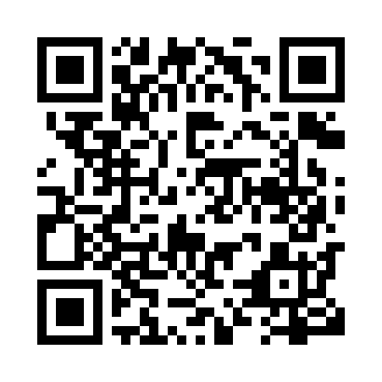

**Prayer times for Quaqtaq, Quebec, Canada**

**Sun 1 Sep 2024 - Mon 30 Sep 2024**

**High Latitude Method: Angle Based Rule**

**Prayer Calculation Method: Islamic Society of North America**

**Asar Calculation Method: Hanafi**

|  |  |  |  |  |  |  |  |
| --- | --- | --- | --- | --- | --- | --- | --- |
| **Date** | **Day** | **Fajr** | **Sunrise** | **Dhuhr** | **Asr** | **Maghrib** | **Isha** |
| 1 | Sun | 3:08 | 5:32 | 12:38 | 5:17 | 7:43 | 10:06 |
| 2 | Mon | 3:12 | 5:35 | 12:38 | 5:14 | 7:40 | 10:01 |
| 3 | Tue | 3:16 | 5:37 | 12:38 | 5:12 | 7:37 | 9:57 |
| 4 | Wed | 3:20 | 5:40 | 12:37 | 5:10 | 7:33 | 9:52 |
| 5 | Thu | 3:24 | 5:42 | 12:37 | 5:07 | 7:30 | 9:47 |
| 6 | Fri | 3:28 | 5:45 | 12:37 | 5:05 | 7:27 | 9:43 |
| 7 | Sat | 3:32 | 5:47 | 12:36 | 5:02 | 7:24 | 9:38 |
| 8 | Sun | 3:36 | 5:50 | 12:36 | 5:00 | 7:21 | 9:34 |
| 9 | Mon | 3:39 | 5:52 | 12:36 | 4:57 | 7:18 | 9:30 |
| 10 | Tue | 3:43 | 5:54 | 12:35 | 4:55 | 7:15 | 9:26 |
| 11 | Wed | 3:46 | 5:57 | 12:35 | 4:52 | 7:11 | 9:21 |
| 12 | Thu | 3:50 | 5:59 | 12:34 | 4:50 | 7:08 | 9:17 |
| 13 | Fri | 3:53 | 6:02 | 12:34 | 4:47 | 7:05 | 9:13 |
| 14 | Sat | 3:56 | 6:04 | 12:34 | 4:45 | 7:02 | 9:09 |
| 15 | Sun | 4:00 | 6:07 | 12:33 | 4:42 | 6:59 | 9:05 |
| 16 | Mon | 4:03 | 6:09 | 12:33 | 4:40 | 6:56 | 9:01 |
| 17 | Tue | 4:06 | 6:12 | 12:33 | 4:37 | 6:52 | 8:57 |
| 18 | Wed | 4:09 | 6:14 | 12:32 | 4:34 | 6:49 | 8:54 |
| 19 | Thu | 4:12 | 6:17 | 12:32 | 4:32 | 6:46 | 8:50 |
| 20 | Fri | 4:15 | 6:19 | 12:32 | 4:29 | 6:43 | 8:46 |
| 21 | Sat | 4:18 | 6:21 | 12:31 | 4:27 | 6:40 | 8:42 |
| 22 | Sun | 4:21 | 6:24 | 12:31 | 4:24 | 6:37 | 8:39 |
| 23 | Mon | 4:24 | 6:26 | 12:31 | 4:21 | 6:33 | 8:35 |
| 24 | Tue | 4:27 | 6:29 | 12:30 | 4:19 | 6:30 | 8:31 |
| 25 | Wed | 4:30 | 6:31 | 12:30 | 4:16 | 6:27 | 8:28 |
| 26 | Thu | 4:33 | 6:34 | 12:30 | 4:13 | 6:24 | 8:24 |
| 27 | Fri | 4:36 | 6:36 | 12:29 | 4:11 | 6:21 | 8:21 |
| 28 | Sat | 4:39 | 6:39 | 12:29 | 4:08 | 6:18 | 8:17 |
| 29 | Sun | 4:42 | 6:41 | 12:29 | 4:05 | 6:14 | 8:14 |
| 30 | Mon | 4:44 | 6:44 | 12:28 | 4:02 | 6:11 | 8:11 |

**Prayer times provided by https://www.salahtimes.com**