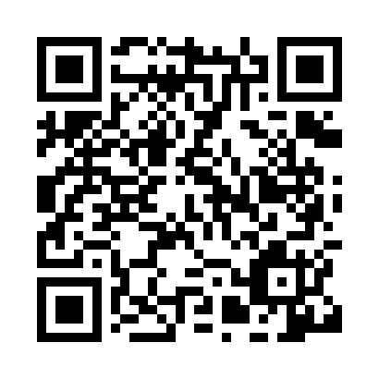
Prayer times for Chōshi, Japan
Wed 1 May 2024 - Fri 31 May 2024
High Latitude Method: None
Prayer Calculation Method: Muslim World League
Asar Calculation Method: Shafi

Date | Day | Fajr | Sunrise | Dhuhr | Asr | Maghrib | Isha
1 | Wed | 3:10 | 4:45 | 11:34 | 3:19 | 6:23 | 7:53
2 | Thu | 3:08 | 4:44 | 11:34 | 3:19 | 6:24 | 7:54
3 | Fri | 3:07 | 4:42 | 11:34 | 3:19 | 6:25 | 7:55
4 | Sat | 3:05 | 4:41 | 11:33 | 3:19 | 6:26 | 7:56
5 | Sun | 3:04 | 4:40 | 11:33 | 3:19 | 6:27 | 7:57
6 | Mon | 3:03 | 4:39 | 11:33 | 3:19 | 6:28 | 7:59
7 | Tue | 3:01 | 4:38 | 11:33 | 3:19 | 6:28 | 8:00
8 | Wed | 3:00 | 4:38 | 11:33 | 3:20 | 6:29 | 8:01
9 | Thu | 2:59 | 4:37 | 11:33 | 3:20 | 6:30 | 8:02
10 | Fri | 2:57 | 4:36 | 11:33 | 3:20 | 6:31 | 8:03
11 | Sat | 2:56 | 4:35 | 11:33 | 3:20 | 6:32 | 8:04
12 | Sun | 2:55 | 4:34 | 11:33 | 3:20 | 6:33 | 8:05
13 | Mon | 2:54 | 4:33 | 11:33 | 3:20 | 6:33 | 8:07
14 | Tue | 2:52 | 4:32 | 11:33 | 3:20 | 6:34 | 8:08
15 | Wed | 2:51 | 4:32 | 11:33 | 3:21 | 6:35 | 8:09
16 | Thu | 2:50 | 4:31 | 11:33 | 3:21 | 6:36 | 8:10
17 | Fri | 2:49 | 4:30 | 11:33 | 3:21 | 6:37 | 8:11
18 | Sat | 2:48 | 4:29 | 11:33 | 3:21 | 6:37 | 8:12
19 | Sun | 2:47 | 4:29 | 11:33 | 3:21 | 6:38 | 8:13
20 | Mon | 2:46 | 4:28 | 11:33 | 3:21 | 6:39 | 8:15
21 | Tue | 2:45 | 4:27 | 11:33 | 3:21 | 6:40 | 8:16
22 | Wed | 2:44 | 4:27 | 11:33 | 3:22 | 6:40 | 8:17
23 | Thu | 2:43 | 4:26 | 11:33 | 3:22 | 6:41 | 8:18
24 | Fri | 2:42 | 4:26 | 11:34 | 3:22 | 6:42 | 8:19
25 | Sat | 2:41 | 4:25 | 11:34 | 3:22 | 6:43 | 8:20
26 | Sun | 2:40 | 4:24 | 11:34 | 3:22 | 6:43 | 8:21
27 | Mon | 2:40 | 4:24 | 11:34 | 3:22 | 6:44 | 8:22
28 | Tue | 2:39 | 4:24 | 11:34 | 3:23 | 6:45 | 8:23
29 | Wed | 2:38 | 4:23 | 11:34 | 3:23 | 6:45 | 8:24
30 | Thu | 2:37 | 4:23 | 11:34 | 3:23 | 6:46 | 8:25
31 | Fri | 2:37 | 4:22 | 11:34 | 3:23 | 6:47 | 8:26
Prayer times provided by https://www.salahtimes.com

