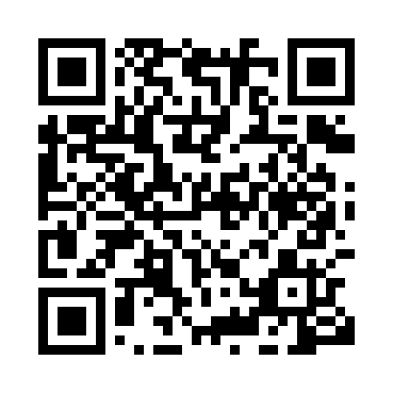
Prayer times for Belingou, Cameroon
Wed 1 May 2024 - Fri 31 May 2024
High Latitude Method: None
Prayer Calculation Method: Muslim World League
Asar Calculation Method: Shafi

Date | Day | Fajr | Sunrise | Dhuhr | Asr | Maghrib | Isha
1 | Wed | 4:39 | 5:50 | 11:58 | 3:17 | 6:06 | 7:14
2 | Thu | 4:38 | 5:50 | 11:58 | 3:18 | 6:06 | 7:14
3 | Fri | 4:38 | 5:50 | 11:58 | 3:18 | 6:06 | 7:14
4 | Sat | 4:38 | 5:50 | 11:58 | 3:18 | 6:06 | 7:14
5 | Sun | 4:38 | 5:50 | 11:58 | 3:18 | 6:06 | 7:15
6 | Mon | 4:37 | 5:50 | 11:58 | 3:19 | 6:07 | 7:15
7 | Tue | 4:37 | 5:49 | 11:58 | 3:19 | 6:07 | 7:15
8 | Wed | 4:37 | 5:49 | 11:58 | 3:19 | 6:07 | 7:15
9 | Thu | 4:36 | 5:49 | 11:58 | 3:19 | 6:07 | 7:15
10 | Fri | 4:36 | 5:49 | 11:58 | 3:20 | 6:07 | 7:15
11 | Sat | 4:36 | 5:49 | 11:58 | 3:20 | 6:07 | 7:15
12 | Sun | 4:36 | 5:49 | 11:58 | 3:20 | 6:07 | 7:16
13 | Mon | 4:36 | 5:49 | 11:58 | 3:20 | 6:07 | 7:16
14 | Tue | 4:35 | 5:49 | 11:58 | 3:21 | 6:07 | 7:16
15 | Wed | 4:35 | 5:48 | 11:58 | 3:21 | 6:07 | 7:16
16 | Thu | 4:35 | 5:48 | 11:58 | 3:21 | 6:07 | 7:16
17 | Fri | 4:35 | 5:48 | 11:58 | 3:21 | 6:07 | 7:17
18 | Sat | 4:35 | 5:48 | 11:58 | 3:22 | 6:07 | 7:17
19 | Sun | 4:35 | 5:48 | 11:58 | 3:22 | 6:08 | 7:17
20 | Mon | 4:34 | 5:48 | 11:58 | 3:22 | 6:08 | 7:17
21 | Tue | 4:34 | 5:48 | 11:58 | 3:22 | 6:08 | 7:18
22 | Wed | 4:34 | 5:48 | 11:58 | 3:23 | 6:08 | 7:18
23 | Thu | 4:34 | 5:48 | 11:58 | 3:23 | 6:08 | 7:18
24 | Fri | 4:34 | 5:48 | 11:58 | 3:23 | 6:08 | 7:18
25 | Sat | 4:34 | 5:48 | 11:58 | 3:23 | 6:08 | 7:19
26 | Sun | 4:34 | 5:48 | 11:59 | 3:24 | 6:09 | 7:19
27 | Mon | 4:34 | 5:48 | 11:59 | 3:24 | 6:09 | 7:19
28 | Tue | 4:34 | 5:49 | 11:59 | 3:24 | 6:09 | 7:19
29 | Wed | 4:34 | 5:49 | 11:59 | 3:25 | 6:09 | 7:20
30 | Thu | 4:34 | 5:49 | 11:59 | 3:25 | 6:09 | 7:20
31 | Fri | 4:34 | 5:49 | 11:59 | 3:25 | 6:10 | 7:20
Prayer times provided by https://www.salahtimes.com

