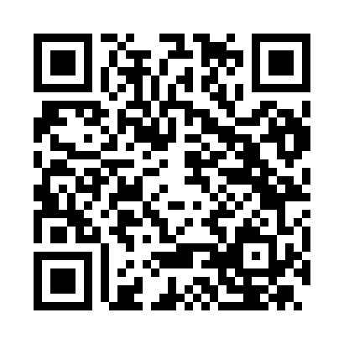
Prayer times for Aliminusa, Italy
Wed 1 May 2024 - Fri 31 May 2024
High Latitude Method: Angle Based Rule
Prayer Calculation Method: Muslim World League
Asar Calculation Method: Hanafi

Date | Day | Fajr | Sunrise | Dhuhr | Asr | Maghrib | Isha
1 | Wed | 4:30 | 6:09 | 1:02 | 5:55 | 7:56 | 9:29
2 | Thu | 4:28 | 6:07 | 1:02 | 5:55 | 7:57 | 9:30
3 | Fri | 4:26 | 6:06 | 1:02 | 5:56 | 7:58 | 9:31
4 | Sat | 4:25 | 6:05 | 1:02 | 5:56 | 7:59 | 9:33
5 | Sun | 4:23 | 6:04 | 1:02 | 5:57 | 7:59 | 9:34
6 | Mon | 4:22 | 6:03 | 1:01 | 5:57 | 8:00 | 9:35
7 | Tue | 4:20 | 6:02 | 1:01 | 5:58 | 8:01 | 9:37
8 | Wed | 4:19 | 6:01 | 1:01 | 5:58 | 8:02 | 9:38
9 | Thu | 4:18 | 6:00 | 1:01 | 5:59 | 8:03 | 9:39
10 | Fri | 4:16 | 5:59 | 1:01 | 5:59 | 8:04 | 9:40
11 | Sat | 4:15 | 5:58 | 1:01 | 6:00 | 8:05 | 9:42
12 | Sun | 4:13 | 5:57 | 1:01 | 6:00 | 8:06 | 9:43
13 | Mon | 4:12 | 5:56 | 1:01 | 6:00 | 8:07 | 9:44
14 | Tue | 4:11 | 5:55 | 1:01 | 6:01 | 8:08 | 9:46
15 | Wed | 4:09 | 5:55 | 1:01 | 6:01 | 8:08 | 9:47
16 | Thu | 4:08 | 5:54 | 1:01 | 6:02 | 8:09 | 9:48
17 | Fri | 4:07 | 5:53 | 1:01 | 6:02 | 8:10 | 9:49
18 | Sat | 4:06 | 5:52 | 1:01 | 6:03 | 8:11 | 9:51
19 | Sun | 4:05 | 5:51 | 1:01 | 6:03 | 8:12 | 9:52
20 | Mon | 4:03 | 5:51 | 1:01 | 6:04 | 8:13 | 9:53
21 | Tue | 4:02 | 5:50 | 1:02 | 6:04 | 8:13 | 9:54
22 | Wed | 4:01 | 5:49 | 1:02 | 6:05 | 8:14 | 9:55
23 | Thu | 4:00 | 5:49 | 1:02 | 6:05 | 8:15 | 9:56
24 | Fri | 3:59 | 5:48 | 1:02 | 6:06 | 8:16 | 9:58
25 | Sat | 3:58 | 5:48 | 1:02 | 6:06 | 8:17 | 9:59
26 | Sun | 3:57 | 5:47 | 1:02 | 6:06 | 8:17 | 10:00
27 | Mon | 3:56 | 5:46 | 1:02 | 6:07 | 8:18 | 10:01
28 | Tue | 3:55 | 5:46 | 1:02 | 6:07 | 8:19 | 10:02
29 | Wed | 3:55 | 5:45 | 1:02 | 6:08 | 8:20 | 10:03
30 | Thu | 3:54 | 5:45 | 1:03 | 6:08 | 8:20 | 10:04
31 | Fri | 3:53 | 5:45 | 1:03 | 6:09 | 8:21 | 10:05
Prayer times provided by https://www.salahtimes.com

