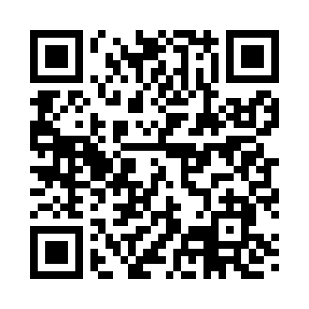
Prayer times for Albrights, New York, USA
Wed 1 May 2024 - Fri 31 May 2024
High Latitude Method: Angle Based Rule
Prayer Calculation Method: Islamic Society of North America
Asar Calculation Method: Shafi

Date | Day | Fajr | Sunrise | Dhuhr | Asr | Maghrib | Isha
1 | Wed | 4:21 | 5:50 | 12:52 | 4:46 | 7:56 | 9:24
2 | Thu | 4:19 | 5:48 | 12:52 | 4:46 | 7:57 | 9:26
3 | Fri | 4:18 | 5:47 | 12:52 | 4:47 | 7:58 | 9:28
4 | Sat | 4:16 | 5:46 | 12:52 | 4:47 | 7:59 | 9:29
5 | Sun | 4:14 | 5:44 | 12:52 | 4:47 | 8:00 | 9:31
6 | Mon | 4:12 | 5:43 | 12:52 | 4:47 | 8:01 | 9:32
7 | Tue | 4:11 | 5:42 | 12:52 | 4:48 | 8:02 | 9:34
8 | Wed | 4:09 | 5:41 | 12:52 | 4:48 | 8:03 | 9:35
9 | Thu | 4:08 | 5:40 | 12:52 | 4:48 | 8:04 | 9:37
10 | Fri | 4:06 | 5:38 | 12:52 | 4:49 | 8:05 | 9:38
11 | Sat | 4:04 | 5:37 | 12:52 | 4:49 | 8:07 | 9:40
12 | Sun | 4:03 | 5:36 | 12:52 | 4:49 | 8:08 | 9:41
13 | Mon | 4:01 | 5:35 | 12:52 | 4:50 | 8:09 | 9:43
14 | Tue | 4:00 | 5:34 | 12:52 | 4:50 | 8:10 | 9:44
15 | Wed | 3:58 | 5:33 | 12:52 | 4:50 | 8:11 | 9:46
16 | Thu | 3:57 | 5:32 | 12:52 | 4:51 | 8:12 | 9:47
17 | Fri | 3:55 | 5:31 | 12:52 | 4:51 | 8:13 | 9:49
18 | Sat | 3:54 | 5:30 | 12:52 | 4:51 | 8:14 | 9:50
19 | Sun | 3:53 | 5:29 | 12:52 | 4:52 | 8:15 | 9:52
20 | Mon | 3:51 | 5:28 | 12:52 | 4:52 | 8:16 | 9:53
21 | Tue | 3:50 | 5:28 | 12:52 | 4:52 | 8:17 | 9:54
22 | Wed | 3:49 | 5:27 | 12:52 | 4:53 | 8:18 | 9:56
23 | Thu | 3:48 | 5:26 | 12:52 | 4:53 | 8:19 | 9:57
24 | Fri | 3:47 | 5:25 | 12:52 | 4:53 | 8:20 | 9:58
25 | Sat | 3:45 | 5:25 | 12:52 | 4:54 | 8:20 | 10:00
26 | Sun | 3:44 | 5:24 | 12:52 | 4:54 | 8:21 | 10:01
27 | Mon | 3:43 | 5:23 | 12:53 | 4:54 | 8:22 | 10:02
28 | Tue | 3:42 | 5:23 | 12:53 | 4:55 | 8:23 | 10:04
29 | Wed | 3:41 | 5:22 | 12:53 | 4:55 | 8:24 | 10:05
30 | Thu | 3:40 | 5:22 | 12:53 | 4:55 | 8:25 | 10:06
31 | Fri | 3:39 | 5:21 | 12:53 | 4:55 | 8:25 | 10:07
Prayer times provided by https://www.salahtimes.com

