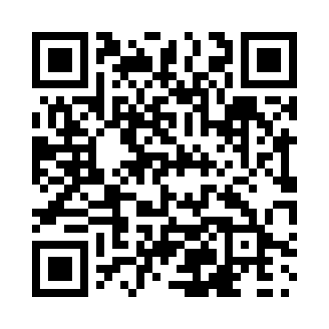
Prayer times for Cawston, British Columbia, Canada
Wed 1 May 2024 - Fri 31 May 2024
High Latitude Method: Angle Based Rule
Prayer Calculation Method: Islamic Society of North America
Asar Calculation Method: Hanafi

Date | Day | Fajr | Sunrise | Dhuhr | Asr | Maghrib | Isha
1 | Wed | 3:49 | 5:36 | 12:56 | 6:01 | 8:17 | 10:04
2 | Thu | 3:47 | 5:35 | 12:56 | 6:02 | 8:18 | 10:06
3 | Fri | 3:44 | 5:33 | 12:56 | 6:03 | 8:19 | 10:09
4 | Sat | 3:42 | 5:31 | 12:56 | 6:04 | 8:21 | 10:11
5 | Sun | 3:39 | 5:30 | 12:56 | 6:05 | 8:22 | 10:13
6 | Mon | 3:37 | 5:28 | 12:56 | 6:06 | 8:24 | 10:16
7 | Tue | 3:35 | 5:27 | 12:56 | 6:06 | 8:25 | 10:18
8 | Wed | 3:32 | 5:25 | 12:56 | 6:07 | 8:27 | 10:20
9 | Thu | 3:30 | 5:24 | 12:55 | 6:08 | 8:28 | 10:23
10 | Fri | 3:27 | 5:22 | 12:55 | 6:09 | 8:30 | 10:25
11 | Sat | 3:25 | 5:21 | 12:55 | 6:10 | 8:31 | 10:27
12 | Sun | 3:23 | 5:19 | 12:55 | 6:11 | 8:32 | 10:30
13 | Mon | 3:20 | 5:18 | 12:55 | 6:11 | 8:34 | 10:32
14 | Tue | 3:18 | 5:16 | 12:55 | 6:12 | 8:35 | 10:34
15 | Wed | 3:16 | 5:15 | 12:55 | 6:13 | 8:36 | 10:37
16 | Thu | 3:13 | 5:14 | 12:55 | 6:14 | 8:38 | 10:39
17 | Fri | 3:11 | 5:13 | 12:56 | 6:15 | 8:39 | 10:41
18 | Sat | 3:09 | 5:11 | 12:56 | 6:15 | 8:40 | 10:44
19 | Sun | 3:06 | 5:10 | 12:56 | 6:16 | 8:42 | 10:46
20 | Mon | 3:04 | 5:09 | 12:56 | 6:17 | 8:43 | 10:48
21 | Tue | 3:02 | 5:08 | 12:56 | 6:18 | 8:44 | 10:50
22 | Wed | 3:01 | 5:07 | 12:56 | 6:18 | 8:45 | 10:51
23 | Thu | 3:01 | 5:06 | 12:56 | 6:19 | 8:47 | 10:51
24 | Fri | 3:01 | 5:05 | 12:56 | 6:20 | 8:48 | 10:52
25 | Sat | 3:00 | 5:04 | 12:56 | 6:21 | 8:49 | 10:53
26 | Sun | 3:00 | 5:03 | 12:56 | 6:21 | 8:50 | 10:53
27 | Mon | 2:59 | 5:02 | 12:56 | 6:22 | 8:51 | 10:54
28 | Tue | 2:59 | 5:01 | 12:56 | 6:23 | 8:52 | 10:55
29 | Wed | 2:59 | 5:00 | 12:57 | 6:23 | 8:53 | 10:55
30 | Thu | 2:58 | 5:00 | 12:57 | 6:24 | 8:54 | 10:56
31 | Fri | 2:58 | 4:59 | 12:57 | 6:24 | 8:55 | 10:56
Prayer times provided by https://www.salahtimes.com

