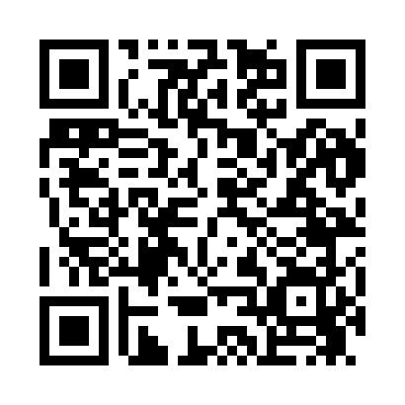
Prayer times for Bates Place, New Mexico, USA
Mon 1 Jul 2024 - Wed 31 Jul 2024
High Latitude Method: Angle Based Rule
Prayer Calculation Method: Islamic Society of North America
Asar Calculation Method: Shafi

Date | Day | Fajr | Sunrise | Dhuhr | Asr | Maghrib | Isha
1 | Mon | 4:16 | 5:42 | 12:58 | 4:46 | 8:13 | 9:39
2 | Tue | 4:16 | 5:43 | 12:58 | 4:46 | 8:13 | 9:39
3 | Wed | 4:17 | 5:43 | 12:58 | 4:47 | 8:13 | 9:39
4 | Thu | 4:18 | 5:44 | 12:58 | 4:47 | 8:13 | 9:39
5 | Fri | 4:18 | 5:44 | 12:58 | 4:47 | 8:12 | 9:38
6 | Sat | 4:19 | 5:45 | 12:59 | 4:47 | 8:12 | 9:38
7 | Sun | 4:20 | 5:45 | 12:59 | 4:47 | 8:12 | 9:37
8 | Mon | 4:20 | 5:46 | 12:59 | 4:47 | 8:12 | 9:37
9 | Tue | 4:21 | 5:47 | 12:59 | 4:47 | 8:11 | 9:37
10 | Wed | 4:22 | 5:47 | 12:59 | 4:48 | 8:11 | 9:36
11 | Thu | 4:23 | 5:48 | 12:59 | 4:48 | 8:11 | 9:35
12 | Fri | 4:24 | 5:48 | 12:59 | 4:48 | 8:10 | 9:35
13 | Sat | 4:24 | 5:49 | 1:00 | 4:48 | 8:10 | 9:34
14 | Sun | 4:25 | 5:50 | 1:00 | 4:48 | 8:09 | 9:34
15 | Mon | 4:26 | 5:50 | 1:00 | 4:48 | 8:09 | 9:33
16 | Tue | 4:27 | 5:51 | 1:00 | 4:48 | 8:08 | 9:32
17 | Wed | 4:28 | 5:52 | 1:00 | 4:48 | 8:08 | 9:31
18 | Thu | 4:29 | 5:52 | 1:00 | 4:48 | 8:07 | 9:31
19 | Fri | 4:30 | 5:53 | 1:00 | 4:48 | 8:07 | 9:30
20 | Sat | 4:31 | 5:54 | 1:00 | 4:48 | 8:06 | 9:29
21 | Sun | 4:32 | 5:54 | 1:00 | 4:48 | 8:06 | 9:28
22 | Mon | 4:33 | 5:55 | 1:00 | 4:48 | 8:05 | 9:27
23 | Tue | 4:34 | 5:56 | 1:00 | 4:48 | 8:04 | 9:26
24 | Wed | 4:35 | 5:57 | 1:00 | 4:48 | 8:03 | 9:25
25 | Thu | 4:36 | 5:57 | 1:00 | 4:48 | 8:03 | 9:24
26 | Fri | 4:37 | 5:58 | 1:00 | 4:47 | 8:02 | 9:23
27 | Sat | 4:38 | 5:59 | 1:00 | 4:47 | 8:01 | 9:22
28 | Sun | 4:39 | 6:00 | 1:00 | 4:47 | 8:00 | 9:21
29 | Mon | 4:40 | 6:00 | 1:00 | 4:47 | 8:00 | 9:20
30 | Tue | 4:41 | 6:01 | 1:00 | 4:47 | 7:59 | 9:19
31 | Wed | 4:42 | 6:02 | 1:00 | 4:47 | 7:58 | 9:18
Prayer times provided by https://www.salahtimes.com

