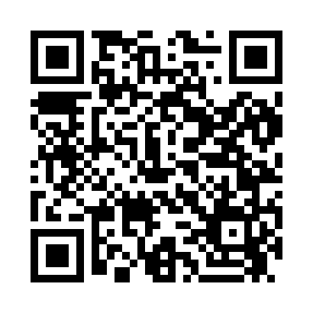
Prayer times for Ashley Place, North Carolina, USA
Mon 1 Jul 2024 - Wed 31 Jul 2024
High Latitude Method: Angle Based Rule
Prayer Calculation Method: Islamic Society of North America
Asar Calculation Method: Shafi

Date | Day | Fajr | Sunrise | Dhuhr | Asr | Maghrib | Isha
1 | Mon | 4:33 | 5:58 | 1:12 | 4:59 | 8:25 | 9:50
2 | Tue | 4:33 | 5:59 | 1:12 | 4:59 | 8:25 | 9:50
3 | Wed | 4:34 | 5:59 | 1:12 | 4:59 | 8:25 | 9:50
4 | Thu | 4:35 | 5:59 | 1:12 | 4:59 | 8:25 | 9:49
5 | Fri | 4:35 | 6:00 | 1:12 | 4:59 | 8:24 | 9:49
6 | Sat | 4:36 | 6:01 | 1:12 | 4:59 | 8:24 | 9:49
7 | Sun | 4:37 | 6:01 | 1:13 | 5:00 | 8:24 | 9:48
8 | Mon | 4:37 | 6:02 | 1:13 | 5:00 | 8:24 | 9:48
9 | Tue | 4:38 | 6:02 | 1:13 | 5:00 | 8:23 | 9:47
10 | Wed | 4:39 | 6:03 | 1:13 | 5:00 | 8:23 | 9:47
11 | Thu | 4:40 | 6:03 | 1:13 | 5:00 | 8:23 | 9:46
12 | Fri | 4:40 | 6:04 | 1:13 | 5:00 | 8:22 | 9:46
13 | Sat | 4:41 | 6:05 | 1:13 | 5:00 | 8:22 | 9:45
14 | Sun | 4:42 | 6:05 | 1:14 | 5:00 | 8:22 | 9:45
15 | Mon | 4:43 | 6:06 | 1:14 | 5:00 | 8:21 | 9:44
16 | Tue | 4:44 | 6:06 | 1:14 | 5:00 | 8:21 | 9:43
17 | Wed | 4:45 | 6:07 | 1:14 | 5:00 | 8:20 | 9:42
18 | Thu | 4:46 | 6:08 | 1:14 | 5:00 | 8:20 | 9:42
19 | Fri | 4:46 | 6:08 | 1:14 | 5:00 | 8:19 | 9:41
20 | Sat | 4:47 | 6:09 | 1:14 | 5:00 | 8:18 | 9:40
21 | Sun | 4:48 | 6:10 | 1:14 | 5:00 | 8:18 | 9:39
22 | Mon | 4:49 | 6:11 | 1:14 | 5:00 | 8:17 | 9:38
23 | Tue | 4:50 | 6:11 | 1:14 | 5:00 | 8:17 | 9:37
24 | Wed | 4:51 | 6:12 | 1:14 | 5:00 | 8:16 | 9:36
25 | Thu | 4:52 | 6:13 | 1:14 | 5:00 | 8:15 | 9:36
26 | Fri | 4:53 | 6:13 | 1:14 | 5:00 | 8:14 | 9:35
27 | Sat | 4:54 | 6:14 | 1:14 | 5:00 | 8:14 | 9:33
28 | Sun | 4:55 | 6:15 | 1:14 | 5:00 | 8:13 | 9:32
29 | Mon | 4:56 | 6:16 | 1:14 | 5:00 | 8:12 | 9:31
30 | Tue | 4:57 | 6:16 | 1:14 | 4:59 | 8:11 | 9:30
31 | Wed | 4:58 | 6:17 | 1:14 | 4:59 | 8:10 | 9:29
Prayer times provided by https://www.salahtimes.com

