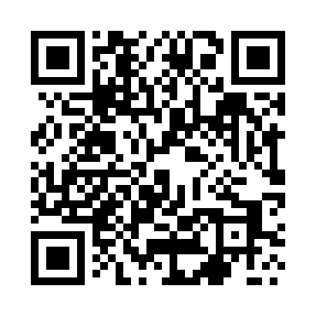
Prayer times for Slosinko, Poland
Mon 1 Apr 2024 - Tue 30 Apr 2024
High Latitude Method: Angle Based Rule
Prayer Calculation Method: Muslim World League
Asar Calculation Method: Hanafi

Date | Day | Fajr | Sunrise | Dhuhr | Asr | Maghrib | Isha
1 | Mon | 4:17 | 6:24 | 12:56 | 5:22 | 7:29 | 9:28
2 | Tue | 4:14 | 6:22 | 12:55 | 5:23 | 7:30 | 9:31
3 | Wed | 4:10 | 6:19 | 12:55 | 5:24 | 7:32 | 9:33
4 | Thu | 4:07 | 6:17 | 12:55 | 5:26 | 7:34 | 9:36
5 | Fri | 4:04 | 6:14 | 12:55 | 5:27 | 7:36 | 9:38
6 | Sat | 4:01 | 6:12 | 12:54 | 5:28 | 7:38 | 9:41
7 | Sun | 3:57 | 6:09 | 12:54 | 5:30 | 7:40 | 9:44
8 | Mon | 3:54 | 6:07 | 12:54 | 5:31 | 7:42 | 9:46
9 | Tue | 3:51 | 6:05 | 12:54 | 5:32 | 7:43 | 9:49
10 | Wed | 3:47 | 6:02 | 12:53 | 5:34 | 7:45 | 9:52
11 | Thu | 3:44 | 6:00 | 12:53 | 5:35 | 7:47 | 9:55
12 | Fri | 3:40 | 5:57 | 12:53 | 5:36 | 7:49 | 9:57
13 | Sat | 3:37 | 5:55 | 12:52 | 5:38 | 7:51 | 10:00
14 | Sun | 3:33 | 5:53 | 12:52 | 5:39 | 7:53 | 10:03
15 | Mon | 3:29 | 5:50 | 12:52 | 5:40 | 7:55 | 10:06
16 | Tue | 3:26 | 5:48 | 12:52 | 5:41 | 7:56 | 10:09
17 | Wed | 3:22 | 5:46 | 12:52 | 5:43 | 7:58 | 10:12
18 | Thu | 3:18 | 5:43 | 12:51 | 5:44 | 8:00 | 10:15
19 | Fri | 3:15 | 5:41 | 12:51 | 5:45 | 8:02 | 10:19
20 | Sat | 3:11 | 5:39 | 12:51 | 5:46 | 8:04 | 10:22
21 | Sun | 3:07 | 5:37 | 12:51 | 5:47 | 8:06 | 10:25
22 | Mon | 3:03 | 5:34 | 12:50 | 5:49 | 8:08 | 10:28
23 | Tue | 2:59 | 5:32 | 12:50 | 5:50 | 8:09 | 10:32
24 | Wed | 2:55 | 5:30 | 12:50 | 5:51 | 8:11 | 10:35
25 | Thu | 2:50 | 5:28 | 12:50 | 5:52 | 8:13 | 10:39
26 | Fri | 2:46 | 5:26 | 12:50 | 5:53 | 8:15 | 10:42
27 | Sat | 2:42 | 5:23 | 12:50 | 5:55 | 8:17 | 10:46
28 | Sun | 2:39 | 5:21 | 12:49 | 5:56 | 8:19 | 10:50
29 | Mon | 2:38 | 5:19 | 12:49 | 5:57 | 8:21 | 10:53
30 | Tue | 2:37 | 5:17 | 12:49 | 5:58 | 8:22 | 10:54
Prayer times provided by https://www.salahtimes.com

