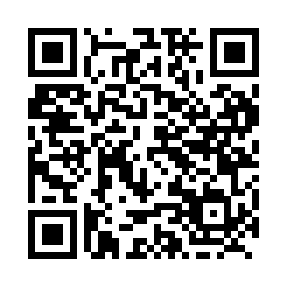

**Prayer times for Lawledge, Manitoba, Canada**

**Sun 1 Sep 2024 - Mon 30 Sep 2024**

**High Latitude Method: Angle Based Rule**

**Prayer Calculation Method: Islamic Society of North America**

**Asar Calculation Method: Hanafi**

|  |  |  |  |  |  |  |  |
| --- | --- | --- | --- | --- | --- | --- | --- |
| **Date** | **Day** | **Fajr** | **Sunrise** | **Dhuhr** | **Asr** | **Maghrib** | **Isha** |
| 1 | Sun | 4:20 | 6:20 | 1:16 | 5:55 | 8:11 | 10:11 |
| 2 | Mon | 4:23 | 6:22 | 1:16 | 5:53 | 8:08 | 10:07 |
| 3 | Tue | 4:26 | 6:24 | 1:16 | 5:51 | 8:06 | 10:03 |
| 4 | Wed | 4:29 | 6:26 | 1:15 | 5:49 | 8:03 | 10:00 |
| 5 | Thu | 4:32 | 6:28 | 1:15 | 5:47 | 8:00 | 9:56 |
| 6 | Fri | 4:35 | 6:30 | 1:15 | 5:45 | 7:58 | 9:53 |
| 7 | Sat | 4:37 | 6:32 | 1:14 | 5:42 | 7:55 | 9:49 |
| 8 | Sun | 4:40 | 6:34 | 1:14 | 5:40 | 7:52 | 9:46 |
| 9 | Mon | 4:43 | 6:36 | 1:14 | 5:38 | 7:49 | 9:43 |
| 10 | Tue | 4:45 | 6:38 | 1:13 | 5:36 | 7:47 | 9:39 |
| 11 | Wed | 4:48 | 6:40 | 1:13 | 5:34 | 7:44 | 9:36 |
| 12 | Thu | 4:51 | 6:43 | 1:12 | 5:31 | 7:41 | 9:33 |
| 13 | Fri | 4:53 | 6:45 | 1:12 | 5:29 | 7:38 | 9:29 |
| 14 | Sat | 4:56 | 6:47 | 1:12 | 5:27 | 7:36 | 9:26 |
| 15 | Sun | 4:58 | 6:49 | 1:11 | 5:25 | 7:33 | 9:23 |
| 16 | Mon | 5:01 | 6:51 | 1:11 | 5:22 | 7:30 | 9:20 |
| 17 | Tue | 5:03 | 6:53 | 1:11 | 5:20 | 7:28 | 9:16 |
| 18 | Wed | 5:06 | 6:55 | 1:10 | 5:18 | 7:25 | 9:13 |
| 19 | Thu | 5:08 | 6:57 | 1:10 | 5:16 | 7:22 | 9:10 |
| 20 | Fri | 5:11 | 6:59 | 1:10 | 5:13 | 7:19 | 9:07 |
| 21 | Sat | 5:13 | 7:01 | 1:09 | 5:11 | 7:17 | 9:04 |
| 22 | Sun | 5:16 | 7:03 | 1:09 | 5:09 | 7:14 | 9:01 |
| 23 | Mon | 5:18 | 7:05 | 1:09 | 5:06 | 7:11 | 8:58 |
| 24 | Tue | 5:20 | 7:07 | 1:08 | 5:04 | 7:08 | 8:55 |
| 25 | Wed | 5:23 | 7:09 | 1:08 | 5:02 | 7:06 | 8:52 |
| 26 | Thu | 5:25 | 7:11 | 1:08 | 4:59 | 7:03 | 8:49 |
| 27 | Fri | 5:27 | 7:13 | 1:07 | 4:57 | 7:00 | 8:46 |
| 28 | Sat | 5:29 | 7:15 | 1:07 | 4:55 | 6:57 | 8:43 |
| 29 | Sun | 5:32 | 7:17 | 1:07 | 4:52 | 6:55 | 8:40 |
| 30 | Mon | 5:34 | 7:19 | 1:06 | 4:50 | 6:52 | 8:37 |

**Prayer times provided by https://www.salahtimes.com**