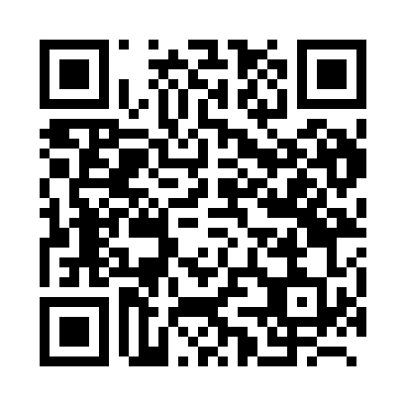
Prayer times for Blikken, Belgium
Mon 1 Apr 2024 - Tue 30 Apr 2024
High Latitude Method: Angle Based Rule
Prayer Calculation Method: Muslim World League
Asar Calculation Method: Shafi

Date | Day | Fajr | Sunrise | Dhuhr | Asr | Maghrib | Isha
1 | Mon | 5:20 | 7:18 | 1:47 | 5:20 | 8:17 | 10:08
2 | Tue | 5:17 | 7:16 | 1:47 | 5:21 | 8:19 | 10:10
3 | Wed | 5:14 | 7:13 | 1:46 | 5:22 | 8:20 | 10:12
4 | Thu | 5:11 | 7:11 | 1:46 | 5:23 | 8:22 | 10:14
5 | Fri | 5:09 | 7:09 | 1:46 | 5:24 | 8:24 | 10:16
6 | Sat | 5:06 | 7:07 | 1:45 | 5:24 | 8:25 | 10:19
7 | Sun | 5:03 | 7:04 | 1:45 | 5:25 | 8:27 | 10:21
8 | Mon | 5:00 | 7:02 | 1:45 | 5:26 | 8:28 | 10:23
9 | Tue | 4:57 | 7:00 | 1:45 | 5:27 | 8:30 | 10:25
10 | Wed | 4:54 | 6:58 | 1:44 | 5:28 | 8:32 | 10:28
11 | Thu | 4:51 | 6:56 | 1:44 | 5:29 | 8:33 | 10:30
12 | Fri | 4:48 | 6:53 | 1:44 | 5:29 | 8:35 | 10:33
13 | Sat | 4:45 | 6:51 | 1:44 | 5:30 | 8:37 | 10:35
14 | Sun | 4:42 | 6:49 | 1:43 | 5:31 | 8:38 | 10:37
15 | Mon | 4:39 | 6:47 | 1:43 | 5:32 | 8:40 | 10:40
16 | Tue | 4:36 | 6:45 | 1:43 | 5:32 | 8:42 | 10:42
17 | Wed | 4:33 | 6:43 | 1:43 | 5:33 | 8:43 | 10:45
18 | Thu | 4:30 | 6:41 | 1:42 | 5:34 | 8:45 | 10:47
19 | Fri | 4:27 | 6:39 | 1:42 | 5:35 | 8:47 | 10:50
20 | Sat | 4:23 | 6:37 | 1:42 | 5:35 | 8:48 | 10:53
21 | Sun | 4:20 | 6:34 | 1:42 | 5:36 | 8:50 | 10:55
22 | Mon | 4:17 | 6:32 | 1:42 | 5:37 | 8:52 | 10:58
23 | Tue | 4:14 | 6:30 | 1:41 | 5:37 | 8:53 | 11:01
24 | Wed | 4:11 | 6:28 | 1:41 | 5:38 | 8:55 | 11:03
25 | Thu | 4:07 | 6:26 | 1:41 | 5:39 | 8:57 | 11:06
26 | Fri | 4:04 | 6:24 | 1:41 | 5:40 | 8:58 | 11:09
27 | Sat | 4:01 | 6:23 | 1:41 | 5:40 | 9:00 | 11:12
28 | Sun | 3:57 | 6:21 | 1:41 | 5:41 | 9:01 | 11:15
29 | Mon | 3:54 | 6:19 | 1:40 | 5:42 | 9:03 | 11:18
30 | Tue | 3:50 | 6:17 | 1:40 | 5:42 | 9:05 | 11:21
Prayer times provided by https://www.salahtimes.com

