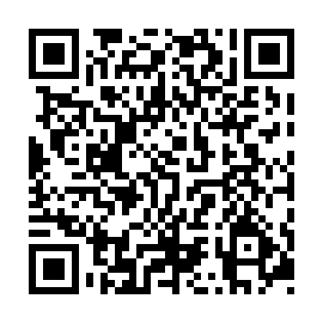
Prayer times for Saint-Simon-sur-Mer, Quebec, Canada
Mon 1 Jul 2024 - Wed 31 Jul 2024
High Latitude Method: Angle Based Rule
Prayer Calculation Method: Islamic Society of North America
Asar Calculation Method: Hanafi

Date | Day | Fajr | Sunrise | Dhuhr | Asr | Maghrib | Isha
1 | Mon | 2:40 | 4:40 | 12:40 | 6:09 | 8:40 | 10:40
2 | Tue | 2:41 | 4:41 | 12:40 | 6:09 | 8:40 | 10:40
3 | Wed | 2:41 | 4:42 | 12:41 | 6:09 | 8:39 | 10:40
4 | Thu | 2:41 | 4:42 | 12:41 | 6:09 | 8:39 | 10:40
5 | Fri | 2:42 | 4:43 | 12:41 | 6:09 | 8:39 | 10:40
6 | Sat | 2:42 | 4:44 | 12:41 | 6:08 | 8:38 | 10:40
7 | Sun | 2:43 | 4:45 | 12:41 | 6:08 | 8:38 | 10:39
8 | Mon | 2:43 | 4:45 | 12:41 | 6:08 | 8:37 | 10:39
9 | Tue | 2:44 | 4:46 | 12:42 | 6:08 | 8:36 | 10:39
10 | Wed | 2:44 | 4:47 | 12:42 | 6:07 | 8:36 | 10:39
11 | Thu | 2:45 | 4:48 | 12:42 | 6:07 | 8:35 | 10:38
12 | Fri | 2:45 | 4:49 | 12:42 | 6:07 | 8:34 | 10:38
13 | Sat | 2:46 | 4:50 | 12:42 | 6:06 | 8:34 | 10:38
14 | Sun | 2:47 | 4:51 | 12:42 | 6:06 | 8:33 | 10:37
15 | Mon | 2:47 | 4:52 | 12:42 | 6:06 | 8:32 | 10:37
16 | Tue | 2:49 | 4:53 | 12:42 | 6:05 | 8:31 | 10:35
17 | Wed | 2:51 | 4:54 | 12:42 | 6:05 | 8:30 | 10:33
18 | Thu | 2:53 | 4:55 | 12:43 | 6:04 | 8:29 | 10:31
19 | Fri | 2:55 | 4:57 | 12:43 | 6:04 | 8:28 | 10:30
20 | Sat | 2:57 | 4:58 | 12:43 | 6:03 | 8:27 | 10:28
21 | Sun | 2:59 | 4:59 | 12:43 | 6:02 | 8:26 | 10:26
22 | Mon | 3:01 | 5:00 | 12:43 | 6:02 | 8:25 | 10:24
23 | Tue | 3:03 | 5:01 | 12:43 | 6:01 | 8:24 | 10:22
24 | Wed | 3:05 | 5:02 | 12:43 | 6:01 | 8:23 | 10:20
25 | Thu | 3:07 | 5:04 | 12:43 | 6:00 | 8:21 | 10:17
26 | Fri | 3:09 | 5:05 | 12:43 | 5:59 | 8:20 | 10:15
27 | Sat | 3:11 | 5:06 | 12:43 | 5:58 | 8:19 | 10:13
28 | Sun | 3:13 | 5:07 | 12:43 | 5:58 | 8:17 | 10:11
29 | Mon | 3:15 | 5:09 | 12:43 | 5:57 | 8:16 | 10:09
30 | Tue | 3:18 | 5:10 | 12:43 | 5:56 | 8:15 | 10:07
31 | Wed | 3:20 | 5:11 | 12:43 | 5:55 | 8:13 | 10:04
Prayer times provided by https://www.salahtimes.com

