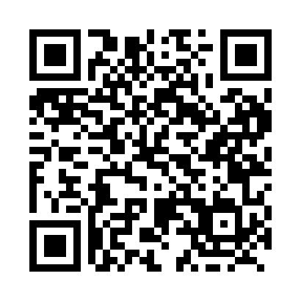

**Prayer times for Qarmait, Quebec, Canada**

**Sun 1 Sep 2024 - Mon 30 Sep 2024**

**High Latitude Method: Angle Based Rule**

**Prayer Calculation Method: Islamic Society of North America**

**Asar Calculation Method: Hanafi**

|  |  |  |  |  |  |  |  |
| --- | --- | --- | --- | --- | --- | --- | --- |
| **Date** | **Day** | **Fajr** | **Sunrise** | **Dhuhr** | **Asr** | **Maghrib** | **Isha** |
| 1 | Sun | 3:21 | 5:35 | 12:38 | 5:16 | 7:39 | 9:53 |
| 2 | Mon | 3:25 | 5:38 | 12:38 | 5:14 | 7:36 | 9:48 |
| 3 | Tue | 3:28 | 5:40 | 12:37 | 5:12 | 7:33 | 9:44 |
| 4 | Wed | 3:32 | 5:42 | 12:37 | 5:10 | 7:30 | 9:40 |
| 5 | Thu | 3:35 | 5:45 | 12:37 | 5:07 | 7:27 | 9:36 |
| 6 | Fri | 3:39 | 5:47 | 12:36 | 5:05 | 7:24 | 9:32 |
| 7 | Sat | 3:42 | 5:49 | 12:36 | 5:03 | 7:21 | 9:28 |
| 8 | Sun | 3:45 | 5:52 | 12:35 | 5:00 | 7:18 | 9:24 |
| 9 | Mon | 3:49 | 5:54 | 12:35 | 4:58 | 7:15 | 9:20 |
| 10 | Tue | 3:52 | 5:56 | 12:35 | 4:56 | 7:12 | 9:16 |
| 11 | Wed | 3:55 | 5:58 | 12:34 | 4:53 | 7:09 | 9:12 |
| 12 | Thu | 3:58 | 6:01 | 12:34 | 4:51 | 7:06 | 9:08 |
| 13 | Fri | 4:01 | 6:03 | 12:34 | 4:48 | 7:03 | 9:05 |
| 14 | Sat | 4:04 | 6:05 | 12:33 | 4:46 | 7:00 | 9:01 |
| 15 | Sun | 4:07 | 6:08 | 12:33 | 4:43 | 6:57 | 8:57 |
| 16 | Mon | 4:10 | 6:10 | 12:33 | 4:41 | 6:54 | 8:53 |
| 17 | Tue | 4:13 | 6:12 | 12:32 | 4:39 | 6:51 | 8:50 |
| 18 | Wed | 4:16 | 6:15 | 12:32 | 4:36 | 6:48 | 8:46 |
| 19 | Thu | 4:19 | 6:17 | 12:32 | 4:34 | 6:45 | 8:43 |
| 20 | Fri | 4:21 | 6:19 | 12:31 | 4:31 | 6:42 | 8:39 |
| 21 | Sat | 4:24 | 6:21 | 12:31 | 4:29 | 6:39 | 8:36 |
| 22 | Sun | 4:27 | 6:24 | 12:31 | 4:26 | 6:36 | 8:32 |
| 23 | Mon | 4:30 | 6:26 | 12:30 | 4:23 | 6:33 | 8:29 |
| 24 | Tue | 4:32 | 6:28 | 12:30 | 4:21 | 6:30 | 8:26 |
| 25 | Wed | 4:35 | 6:31 | 12:29 | 4:18 | 6:27 | 8:22 |
| 26 | Thu | 4:38 | 6:33 | 12:29 | 4:16 | 6:24 | 8:19 |
| 27 | Fri | 4:40 | 6:35 | 12:29 | 4:13 | 6:21 | 8:16 |
| 28 | Sat | 4:43 | 6:38 | 12:28 | 4:11 | 6:18 | 8:12 |
| 29 | Sun | 4:46 | 6:40 | 12:28 | 4:08 | 6:15 | 8:09 |
| 30 | Mon | 4:48 | 6:42 | 12:28 | 4:06 | 6:12 | 8:06 |

**Prayer times provided by https://www.salahtimes.com**