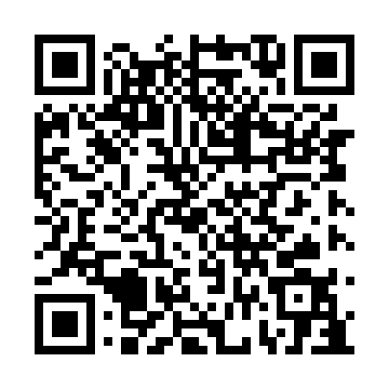

**Prayer times for Duck Lake Post, Manitoba, Canada**

**Sun 1 Sep 2024 - Mon 30 Sep 2024**

**High Latitude Method: Angle Based Rule**

**Prayer Calculation Method: Islamic Society of North America**

**Asar Calculation Method: Hanafi**

|  |  |  |  |  |  |  |  |
| --- | --- | --- | --- | --- | --- | --- | --- |
| **Date** | **Day** | **Fajr** | **Sunrise** | **Dhuhr** | **Asr** | **Maghrib** | **Isha** |
| 1 | Sun | 4:16 | 6:29 | 1:31 | 6:09 | 8:31 | 10:43 |
| 2 | Mon | 4:20 | 6:31 | 1:30 | 6:07 | 8:28 | 10:39 |
| 3 | Tue | 4:23 | 6:34 | 1:30 | 6:05 | 8:25 | 10:35 |
| 4 | Wed | 4:27 | 6:36 | 1:30 | 6:02 | 8:22 | 10:31 |
| 5 | Thu | 4:30 | 6:38 | 1:29 | 6:00 | 8:19 | 10:27 |
| 6 | Fri | 4:33 | 6:40 | 1:29 | 5:58 | 8:16 | 10:23 |
| 7 | Sat | 4:37 | 6:43 | 1:29 | 5:56 | 8:13 | 10:19 |
| 8 | Sun | 4:40 | 6:45 | 1:28 | 5:53 | 8:10 | 10:15 |
| 9 | Mon | 4:43 | 6:47 | 1:28 | 5:51 | 8:07 | 10:11 |
| 10 | Tue | 4:46 | 6:50 | 1:28 | 5:48 | 8:04 | 10:07 |
| 11 | Wed | 4:49 | 6:52 | 1:27 | 5:46 | 8:01 | 10:03 |
| 12 | Thu | 4:52 | 6:54 | 1:27 | 5:44 | 7:58 | 10:00 |
| 13 | Fri | 4:55 | 6:56 | 1:27 | 5:41 | 7:55 | 9:56 |
| 14 | Sat | 4:58 | 6:59 | 1:26 | 5:39 | 7:52 | 9:52 |
| 15 | Sun | 5:01 | 7:01 | 1:26 | 5:36 | 7:49 | 9:49 |
| 16 | Mon | 5:04 | 7:03 | 1:26 | 5:34 | 7:46 | 9:45 |
| 17 | Tue | 5:07 | 7:05 | 1:25 | 5:32 | 7:43 | 9:41 |
| 18 | Wed | 5:10 | 7:08 | 1:25 | 5:29 | 7:40 | 9:38 |
| 19 | Thu | 5:13 | 7:10 | 1:24 | 5:27 | 7:37 | 9:34 |
| 20 | Fri | 5:16 | 7:12 | 1:24 | 5:24 | 7:35 | 9:31 |
| 21 | Sat | 5:18 | 7:15 | 1:24 | 5:22 | 7:32 | 9:27 |
| 22 | Sun | 5:21 | 7:17 | 1:23 | 5:19 | 7:29 | 9:24 |
| 23 | Mon | 5:24 | 7:19 | 1:23 | 5:17 | 7:26 | 9:21 |
| 24 | Tue | 5:26 | 7:21 | 1:23 | 5:14 | 7:23 | 9:17 |
| 25 | Wed | 5:29 | 7:24 | 1:22 | 5:11 | 7:20 | 9:14 |
| 26 | Thu | 5:32 | 7:26 | 1:22 | 5:09 | 7:17 | 9:11 |
| 27 | Fri | 5:34 | 7:28 | 1:22 | 5:06 | 7:14 | 9:07 |
| 28 | Sat | 5:37 | 7:31 | 1:21 | 5:04 | 7:11 | 9:04 |
| 29 | Sun | 5:39 | 7:33 | 1:21 | 5:01 | 7:08 | 9:01 |
| 30 | Mon | 5:42 | 7:35 | 1:21 | 4:59 | 7:05 | 8:58 |

**Prayer times provided by https://www.salahtimes.com**