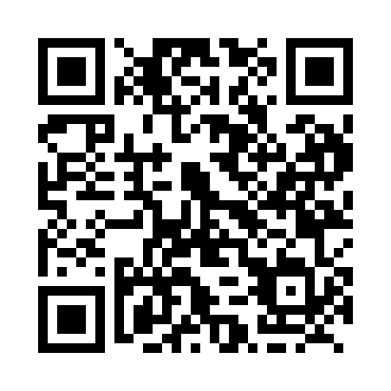
Prayer times for Golden Bay, Manitoba, Canada
Wed 1 May 2024 - Fri 31 May 2024
High Latitude Method: Angle Based Rule
Prayer Calculation Method: Islamic Society of North America
Asar Calculation Method: Hanafi

Date | Day | Fajr | Sunrise | Dhuhr | Asr | Maghrib | Isha
1 | Wed | 4:10 | 6:00 | 1:23 | 6:28 | 8:45 | 10:36
2 | Thu | 4:07 | 5:59 | 1:22 | 6:29 | 8:47 | 10:39
3 | Fri | 4:05 | 5:57 | 1:22 | 6:30 | 8:49 | 10:41
4 | Sat | 4:02 | 5:55 | 1:22 | 6:31 | 8:50 | 10:44
5 | Sun | 4:00 | 5:54 | 1:22 | 6:32 | 8:52 | 10:46
6 | Mon | 3:57 | 5:52 | 1:22 | 6:33 | 8:53 | 10:49
7 | Tue | 3:54 | 5:50 | 1:22 | 6:34 | 8:55 | 10:51
8 | Wed | 3:52 | 5:49 | 1:22 | 6:35 | 8:56 | 10:54
9 | Thu | 3:49 | 5:47 | 1:22 | 6:36 | 8:57 | 10:56
10 | Fri | 3:47 | 5:46 | 1:22 | 6:37 | 8:59 | 10:59
11 | Sat | 3:44 | 5:44 | 1:22 | 6:38 | 9:00 | 11:01
12 | Sun | 3:41 | 5:43 | 1:22 | 6:38 | 9:02 | 11:04
13 | Mon | 3:39 | 5:41 | 1:22 | 6:39 | 9:03 | 11:06
14 | Tue | 3:36 | 5:40 | 1:22 | 6:40 | 9:05 | 11:09
15 | Wed | 3:34 | 5:38 | 1:22 | 6:41 | 9:06 | 11:11
16 | Thu | 3:31 | 5:37 | 1:22 | 6:42 | 9:08 | 11:14
17 | Fri | 3:29 | 5:36 | 1:22 | 6:43 | 9:09 | 11:16
18 | Sat | 3:28 | 5:34 | 1:22 | 6:43 | 9:10 | 11:16
19 | Sun | 3:28 | 5:33 | 1:22 | 6:44 | 9:12 | 11:17
20 | Mon | 3:27 | 5:32 | 1:22 | 6:45 | 9:13 | 11:18
21 | Tue | 3:27 | 5:31 | 1:22 | 6:46 | 9:14 | 11:18
22 | Wed | 3:26 | 5:30 | 1:22 | 6:46 | 9:15 | 11:19
23 | Thu | 3:26 | 5:29 | 1:22 | 6:47 | 9:17 | 11:20
24 | Fri | 3:25 | 5:28 | 1:22 | 6:48 | 9:18 | 11:20
25 | Sat | 3:25 | 5:27 | 1:23 | 6:49 | 9:19 | 11:21
26 | Sun | 3:24 | 5:26 | 1:23 | 6:49 | 9:20 | 11:22
27 | Mon | 3:24 | 5:25 | 1:23 | 6:50 | 9:22 | 11:22
28 | Tue | 3:23 | 5:24 | 1:23 | 6:51 | 9:23 | 11:23
29 | Wed | 3:23 | 5:23 | 1:23 | 6:51 | 9:24 | 11:24
30 | Thu | 3:23 | 5:22 | 1:23 | 6:52 | 9:25 | 11:24
31 | Fri | 3:22 | 5:21 | 1:23 | 6:53 | 9:26 | 11:25
Prayer times provided by https://www.salahtimes.com

