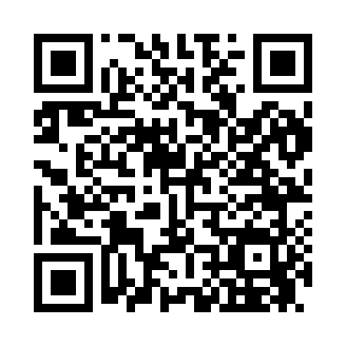
Prayer times for Cosfort, North Carolina, USA
Mon 1 Apr 2024 - Tue 30 Apr 2024
High Latitude Method: Angle Based Rule
Prayer Calculation Method: Islamic Society of North America
Asar Calculation Method: Shafi

Date | Day | Fajr | Sunrise | Dhuhr | Asr | Maghrib | Isha
1 | Mon | 5:59 | 7:11 | 1:29 | 5:03 | 7:48 | 9:00
2 | Tue | 5:57 | 7:09 | 1:29 | 5:03 | 7:49 | 9:01
3 | Wed | 5:56 | 7:08 | 1:28 | 5:04 | 7:49 | 9:02
4 | Thu | 5:54 | 7:07 | 1:28 | 5:04 | 7:50 | 9:03
5 | Fri | 5:53 | 7:05 | 1:28 | 5:04 | 7:51 | 9:04
6 | Sat | 5:51 | 7:04 | 1:28 | 5:04 | 7:52 | 9:05
7 | Sun | 5:50 | 7:02 | 1:27 | 5:04 | 7:53 | 9:06
8 | Mon | 5:48 | 7:01 | 1:27 | 5:05 | 7:54 | 9:07
9 | Tue | 5:47 | 7:00 | 1:27 | 5:05 | 7:55 | 9:08
10 | Wed | 5:45 | 6:58 | 1:26 | 5:05 | 7:55 | 9:09
11 | Thu | 5:43 | 6:57 | 1:26 | 5:05 | 7:56 | 9:10
12 | Fri | 5:42 | 6:55 | 1:26 | 5:05 | 7:57 | 9:11
13 | Sat | 5:40 | 6:54 | 1:26 | 5:06 | 7:58 | 9:12
14 | Sun | 5:39 | 6:53 | 1:25 | 5:06 | 7:59 | 9:13
15 | Mon | 5:37 | 6:51 | 1:25 | 5:06 | 8:00 | 9:14
16 | Tue | 5:36 | 6:50 | 1:25 | 5:06 | 8:00 | 9:15
17 | Wed | 5:34 | 6:49 | 1:25 | 5:06 | 8:01 | 9:16
18 | Thu | 5:33 | 6:47 | 1:25 | 5:06 | 8:02 | 9:17
19 | Fri | 5:31 | 6:46 | 1:24 | 5:06 | 8:03 | 9:18
20 | Sat | 5:30 | 6:45 | 1:24 | 5:07 | 8:04 | 9:19
21 | Sun | 5:28 | 6:44 | 1:24 | 5:07 | 8:05 | 9:20
22 | Mon | 5:27 | 6:42 | 1:24 | 5:07 | 8:06 | 9:21
23 | Tue | 5:25 | 6:41 | 1:24 | 5:07 | 8:06 | 9:23
24 | Wed | 5:24 | 6:40 | 1:23 | 5:07 | 8:07 | 9:24
25 | Thu | 5:22 | 6:39 | 1:23 | 5:07 | 8:08 | 9:25
26 | Fri | 5:21 | 6:38 | 1:23 | 5:07 | 8:09 | 9:26
27 | Sat | 5:20 | 6:36 | 1:23 | 5:07 | 8:10 | 9:27
28 | Sun | 5:18 | 6:35 | 1:23 | 5:08 | 8:11 | 9:28
29 | Mon | 5:17 | 6:34 | 1:23 | 5:08 | 8:12 | 9:29
30 | Tue | 5:15 | 6:33 | 1:22 | 5:08 | 8:12 | 9:30
Prayer times provided by https://www.salahtimes.com

