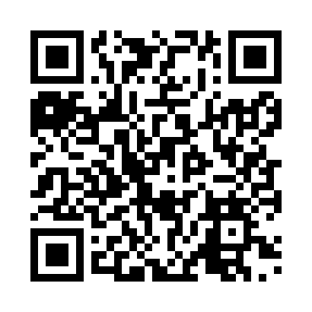
Prayer times for Irbid, Jordan
Wed 1 May 2024 - Fri 31 May 2024
High Latitude Method: None
Prayer Calculation Method: Umm al-Qura, Makkah
Asar Calculation Method: Shafi

Date | Day | Fajr | Sunrise | Dhuhr | Asr | Maghrib | Isha
1 | Wed | 4:17 | 5:50 | 12:34 | 4:14 | 7:18 | 8:48
2 | Thu | 4:15 | 5:49 | 12:34 | 4:14 | 7:19 | 8:49
3 | Fri | 4:14 | 5:48 | 12:33 | 4:14 | 7:20 | 8:50
4 | Sat | 4:13 | 5:47 | 12:33 | 4:14 | 7:20 | 8:50
5 | Sun | 4:12 | 5:46 | 12:33 | 4:14 | 7:21 | 8:51
6 | Mon | 4:10 | 5:45 | 12:33 | 4:14 | 7:22 | 8:52
7 | Tue | 4:09 | 5:44 | 12:33 | 4:14 | 7:23 | 8:53
8 | Wed | 4:08 | 5:43 | 12:33 | 4:14 | 7:23 | 8:53
9 | Thu | 4:07 | 5:42 | 12:33 | 4:14 | 7:24 | 8:54
10 | Fri | 4:06 | 5:42 | 12:33 | 4:14 | 7:25 | 8:55
11 | Sat | 4:05 | 5:41 | 12:33 | 4:14 | 7:25 | 8:55
12 | Sun | 4:04 | 5:40 | 12:33 | 4:15 | 7:26 | 8:56
13 | Mon | 4:03 | 5:39 | 12:33 | 4:15 | 7:27 | 8:57
14 | Tue | 4:02 | 5:39 | 12:33 | 4:15 | 7:28 | 8:58
15 | Wed | 4:01 | 5:38 | 12:33 | 4:15 | 7:28 | 8:58
16 | Thu | 4:00 | 5:37 | 12:33 | 4:15 | 7:29 | 8:59
17 | Fri | 3:59 | 5:37 | 12:33 | 4:15 | 7:30 | 9:00
18 | Sat | 3:58 | 5:36 | 12:33 | 4:15 | 7:30 | 9:00
19 | Sun | 3:57 | 5:35 | 12:33 | 4:15 | 7:31 | 9:01
20 | Mon | 3:56 | 5:35 | 12:33 | 4:15 | 7:32 | 9:02
21 | Tue | 3:55 | 5:34 | 12:33 | 4:15 | 7:32 | 9:02
22 | Wed | 3:54 | 5:34 | 12:33 | 4:15 | 7:33 | 9:03
23 | Thu | 3:53 | 5:33 | 12:33 | 4:15 | 7:34 | 9:04
24 | Fri | 3:53 | 5:33 | 12:33 | 4:15 | 7:34 | 9:04
25 | Sat | 3:52 | 5:32 | 12:34 | 4:15 | 7:35 | 9:05
26 | Sun | 3:51 | 5:32 | 12:34 | 4:16 | 7:36 | 9:06
27 | Mon | 3:51 | 5:32 | 12:34 | 4:16 | 7:36 | 9:06
28 | Tue | 3:50 | 5:31 | 12:34 | 4:16 | 7:37 | 9:07
29 | Wed | 3:49 | 5:31 | 12:34 | 4:16 | 7:38 | 9:08
30 | Thu | 3:49 | 5:31 | 12:34 | 4:16 | 7:38 | 9:08
31 | Fri | 3:48 | 5:30 | 12:34 | 4:16 | 7:39 | 9:09
Prayer times provided by https://www.salahtimes.com

