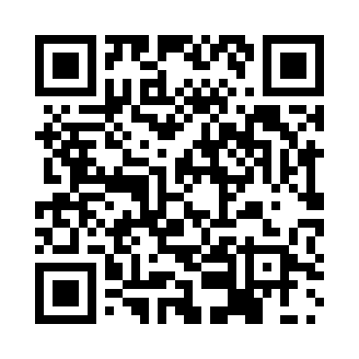
Prayer times for Blocquemont, Belgium
Wed 1 May 2024 - Fri 31 May 2024
High Latitude Method: Angle Based Rule
Prayer Calculation Method: Muslim World League
Asar Calculation Method: Shafi

Date | Day | Fajr | Sunrise | Dhuhr | Asr | Maghrib | Isha
1 | Wed | 3:53 | 6:15 | 1:37 | 5:39 | 9:01 | 11:12
2 | Thu | 3:50 | 6:13 | 1:37 | 5:40 | 9:02 | 11:15
3 | Fri | 3:47 | 6:12 | 1:37 | 5:40 | 9:04 | 11:18
4 | Sat | 3:44 | 6:10 | 1:37 | 5:41 | 9:05 | 11:21
5 | Sun | 3:40 | 6:08 | 1:37 | 5:42 | 9:07 | 11:24
6 | Mon | 3:37 | 6:06 | 1:37 | 5:42 | 9:08 | 11:26
7 | Tue | 3:34 | 6:05 | 1:37 | 5:43 | 9:10 | 11:29
8 | Wed | 3:30 | 6:03 | 1:37 | 5:43 | 9:11 | 11:32
9 | Thu | 3:27 | 6:02 | 1:37 | 5:44 | 9:13 | 11:35
10 | Fri | 3:24 | 6:00 | 1:37 | 5:45 | 9:14 | 11:38
11 | Sat | 3:22 | 5:58 | 1:37 | 5:45 | 9:16 | 11:41
12 | Sun | 3:21 | 5:57 | 1:37 | 5:46 | 9:17 | 11:44
13 | Mon | 3:20 | 5:56 | 1:37 | 5:46 | 9:19 | 11:45
14 | Tue | 3:20 | 5:54 | 1:37 | 5:47 | 9:20 | 11:46
15 | Wed | 3:19 | 5:53 | 1:37 | 5:47 | 9:21 | 11:46
16 | Thu | 3:19 | 5:51 | 1:37 | 5:48 | 9:23 | 11:47
17 | Fri | 3:18 | 5:50 | 1:37 | 5:48 | 9:24 | 11:48
18 | Sat | 3:18 | 5:49 | 1:37 | 5:49 | 9:26 | 11:48
19 | Sun | 3:17 | 5:47 | 1:37 | 5:50 | 9:27 | 11:49
20 | Mon | 3:17 | 5:46 | 1:37 | 5:50 | 9:28 | 11:49
21 | Tue | 3:16 | 5:45 | 1:37 | 5:51 | 9:30 | 11:50
22 | Wed | 3:16 | 5:44 | 1:37 | 5:51 | 9:31 | 11:51
23 | Thu | 3:16 | 5:43 | 1:37 | 5:52 | 9:32 | 11:51
24 | Fri | 3:15 | 5:42 | 1:37 | 5:52 | 9:33 | 11:52
25 | Sat | 3:15 | 5:41 | 1:37 | 5:53 | 9:35 | 11:52
26 | Sun | 3:14 | 5:40 | 1:37 | 5:53 | 9:36 | 11:53
27 | Mon | 3:14 | 5:39 | 1:38 | 5:54 | 9:37 | 11:53
28 | Tue | 3:14 | 5:38 | 1:38 | 5:54 | 9:38 | 11:54
29 | Wed | 3:14 | 5:37 | 1:38 | 5:54 | 9:39 | 11:55
30 | Thu | 3:13 | 5:36 | 1:38 | 5:55 | 9:40 | 11:55
31 | Fri | 3:13 | 5:35 | 1:38 | 5:55 | 9:41 | 11:56
Prayer times provided by https://www.salahtimes.com

