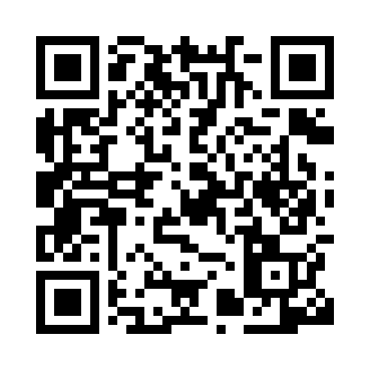
Prayer times for Espoo, Uusimaa, Finland
Mon 1 Apr 2024 - Tue 30 Apr 2024
High Latitude Method: Angle Based Rule
Prayer Calculation Method: Muslim World League
Asar Calculation Method: Hanafi

Date | Day | Fajr | Sunrise | Dhuhr | Asr | Maghrib | Isha
1 | Mon | 4:05 | 6:45 | 1:25 | 5:47 | 8:06 | 10:36
2 | Tue | 4:00 | 6:42 | 1:25 | 5:49 | 8:09 | 10:40
3 | Wed | 3:55 | 6:39 | 1:25 | 5:51 | 8:11 | 10:44
4 | Thu | 3:50 | 6:36 | 1:24 | 5:52 | 8:14 | 10:48
5 | Fri | 3:45 | 6:33 | 1:24 | 5:54 | 8:16 | 10:52
6 | Sat | 3:40 | 6:30 | 1:24 | 5:56 | 8:19 | 10:57
7 | Sun | 3:35 | 6:27 | 1:23 | 5:58 | 8:21 | 11:01
8 | Mon | 3:29 | 6:24 | 1:23 | 5:59 | 8:24 | 11:06
9 | Tue | 3:24 | 6:21 | 1:23 | 6:01 | 8:26 | 11:10
10 | Wed | 3:21 | 6:18 | 1:23 | 6:03 | 8:29 | 11:15
11 | Thu | 3:20 | 6:15 | 1:22 | 6:05 | 8:31 | 11:17
12 | Fri | 3:18 | 6:12 | 1:22 | 6:06 | 8:34 | 11:17
13 | Sat | 3:17 | 6:09 | 1:22 | 6:08 | 8:36 | 11:18
14 | Sun | 3:16 | 6:06 | 1:22 | 6:10 | 8:39 | 11:19
15 | Mon | 3:14 | 6:03 | 1:21 | 6:11 | 8:41 | 11:20
16 | Tue | 3:13 | 6:00 | 1:21 | 6:13 | 8:44 | 11:21
17 | Wed | 3:12 | 5:57 | 1:21 | 6:15 | 8:46 | 11:22
18 | Thu | 3:10 | 5:54 | 1:21 | 6:16 | 8:49 | 11:23
19 | Fri | 3:09 | 5:51 | 1:20 | 6:18 | 8:51 | 11:24
20 | Sat | 3:08 | 5:48 | 1:20 | 6:19 | 8:54 | 11:25
21 | Sun | 3:07 | 5:45 | 1:20 | 6:21 | 8:56 | 11:26
22 | Mon | 3:05 | 5:42 | 1:20 | 6:23 | 8:59 | 11:27
23 | Tue | 3:04 | 5:40 | 1:20 | 6:24 | 9:01 | 11:28
24 | Wed | 3:03 | 5:37 | 1:19 | 6:26 | 9:04 | 11:29
25 | Thu | 3:02 | 5:34 | 1:19 | 6:27 | 9:06 | 11:30
26 | Fri | 3:00 | 5:31 | 1:19 | 6:29 | 9:09 | 11:31
27 | Sat | 2:59 | 5:28 | 1:19 | 6:30 | 9:11 | 11:32
28 | Sun | 2:58 | 5:25 | 1:19 | 6:32 | 9:14 | 11:33
29 | Mon | 2:57 | 5:23 | 1:19 | 6:33 | 9:16 | 11:34
30 | Tue | 2:55 | 5:20 | 1:19 | 6:35 | 9:19 | 11:35
Prayer times provided by https://www.salahtimes.com

