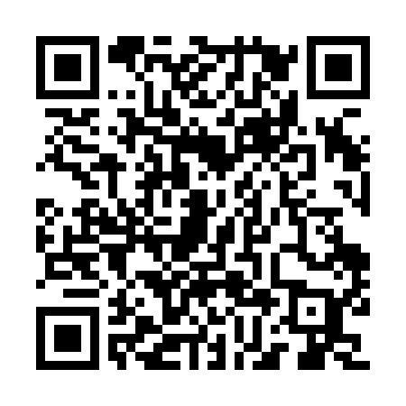
Prayer times for Uishakutshuakamau, Quebec, Canada
Wed 1 May 2024 - Fri 31 May 2024
High Latitude Method: Angle Based Rule
Prayer Calculation Method: Islamic Society of North America
Asar Calculation Method: Hanafi

Date | Day | Fajr | Sunrise | Dhuhr | Asr | Maghrib | Isha
1 | Wed | 2:24 | 4:32 | 12:16 | 5:29 | 8:02 | 10:09
2 | Thu | 2:23 | 4:29 | 12:16 | 5:31 | 8:04 | 10:10
3 | Fri | 2:22 | 4:27 | 12:16 | 5:32 | 8:06 | 10:11
4 | Sat | 2:21 | 4:25 | 12:16 | 5:33 | 8:08 | 10:12
5 | Sun | 2:19 | 4:23 | 12:16 | 5:34 | 8:10 | 10:13
6 | Mon | 2:18 | 4:20 | 12:16 | 5:35 | 8:12 | 10:14
7 | Tue | 2:17 | 4:18 | 12:16 | 5:37 | 8:14 | 10:15
8 | Wed | 2:16 | 4:16 | 12:15 | 5:38 | 8:16 | 10:16
9 | Thu | 2:15 | 4:14 | 12:15 | 5:39 | 8:18 | 10:17
10 | Fri | 2:14 | 4:12 | 12:15 | 5:40 | 8:20 | 10:18
11 | Sat | 2:13 | 4:10 | 12:15 | 5:41 | 8:22 | 10:19
12 | Sun | 2:12 | 4:08 | 12:15 | 5:42 | 8:24 | 10:20
13 | Mon | 2:11 | 4:06 | 12:15 | 5:44 | 8:26 | 10:21
14 | Tue | 2:10 | 4:04 | 12:15 | 5:45 | 8:28 | 10:22
15 | Wed | 2:09 | 4:02 | 12:15 | 5:46 | 8:30 | 10:23
16 | Thu | 2:08 | 4:00 | 12:15 | 5:47 | 8:31 | 10:24
17 | Fri | 2:07 | 3:58 | 12:15 | 5:48 | 8:33 | 10:25
18 | Sat | 2:06 | 3:57 | 12:15 | 5:49 | 8:35 | 10:26
19 | Sun | 2:05 | 3:55 | 12:16 | 5:50 | 8:37 | 10:26
20 | Mon | 2:05 | 3:53 | 12:16 | 5:51 | 8:39 | 10:27
21 | Tue | 2:04 | 3:52 | 12:16 | 5:52 | 8:41 | 10:28
22 | Wed | 2:03 | 3:50 | 12:16 | 5:53 | 8:42 | 10:29
23 | Thu | 2:02 | 3:48 | 12:16 | 5:54 | 8:44 | 10:30
24 | Fri | 2:02 | 3:47 | 12:16 | 5:55 | 8:46 | 10:31
25 | Sat | 2:01 | 3:46 | 12:16 | 5:56 | 8:47 | 10:32
26 | Sun | 2:00 | 3:44 | 12:16 | 5:57 | 8:49 | 10:33
27 | Mon | 2:00 | 3:43 | 12:16 | 5:57 | 8:51 | 10:34
28 | Tue | 1:59 | 3:41 | 12:16 | 5:58 | 8:52 | 10:34
29 | Wed | 1:59 | 3:40 | 12:17 | 5:59 | 8:54 | 10:35
30 | Thu | 1:58 | 3:39 | 12:17 | 6:00 | 8:55 | 10:36
31 | Fri | 1:57 | 3:38 | 12:17 | 6:01 | 8:56 | 10:37
Prayer times provided by https://www.salahtimes.com

