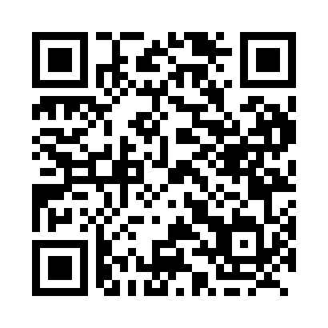
Prayer times for Bouchie Lake, British Columbia, Canada
Wed 1 May 2024 - Fri 31 May 2024
High Latitude Method: Angle Based Rule
Prayer Calculation Method: Islamic Society of North America
Asar Calculation Method: Hanafi

Date | Day | Fajr | Sunrise | Dhuhr | Asr | Maghrib | Isha
1 | Wed | 3:31 | 5:36 | 1:07 | 6:17 | 8:40 | 10:45
2 | Thu | 3:28 | 5:34 | 1:07 | 6:18 | 8:42 | 10:49
3 | Fri | 3:24 | 5:32 | 1:07 | 6:19 | 8:43 | 10:52
4 | Sat | 3:21 | 5:30 | 1:07 | 6:20 | 8:45 | 10:55
5 | Sun | 3:18 | 5:28 | 1:07 | 6:21 | 8:47 | 10:57
6 | Mon | 3:17 | 5:26 | 1:07 | 6:22 | 8:49 | 10:58
7 | Tue | 3:16 | 5:24 | 1:07 | 6:23 | 8:50 | 10:59
8 | Wed | 3:15 | 5:23 | 1:07 | 6:24 | 8:52 | 11:00
9 | Thu | 3:14 | 5:21 | 1:07 | 6:25 | 8:54 | 11:00
10 | Fri | 3:13 | 5:19 | 1:07 | 6:26 | 8:55 | 11:01
11 | Sat | 3:12 | 5:17 | 1:07 | 6:27 | 8:57 | 11:02
12 | Sun | 3:11 | 5:16 | 1:07 | 6:28 | 8:59 | 11:03
13 | Mon | 3:11 | 5:14 | 1:07 | 6:29 | 9:00 | 11:04
14 | Tue | 3:10 | 5:12 | 1:07 | 6:30 | 9:02 | 11:05
15 | Wed | 3:09 | 5:11 | 1:07 | 6:31 | 9:04 | 11:05
16 | Thu | 3:08 | 5:09 | 1:07 | 6:32 | 9:05 | 11:06
17 | Fri | 3:08 | 5:08 | 1:07 | 6:33 | 9:07 | 11:07
18 | Sat | 3:07 | 5:06 | 1:07 | 6:34 | 9:08 | 11:08
19 | Sun | 3:06 | 5:05 | 1:07 | 6:35 | 9:10 | 11:09
20 | Mon | 3:05 | 5:03 | 1:07 | 6:35 | 9:11 | 11:09
21 | Tue | 3:05 | 5:02 | 1:07 | 6:36 | 9:13 | 11:10
22 | Wed | 3:04 | 5:01 | 1:07 | 6:37 | 9:14 | 11:11
23 | Thu | 3:04 | 5:00 | 1:07 | 6:38 | 9:16 | 11:12
24 | Fri | 3:03 | 4:58 | 1:07 | 6:39 | 9:17 | 11:12
25 | Sat | 3:02 | 4:57 | 1:07 | 6:40 | 9:18 | 11:13
26 | Sun | 3:02 | 4:56 | 1:08 | 6:40 | 9:20 | 11:14
27 | Mon | 3:01 | 4:55 | 1:08 | 6:41 | 9:21 | 11:15
28 | Tue | 3:01 | 4:54 | 1:08 | 6:42 | 9:22 | 11:15
29 | Wed | 3:01 | 4:53 | 1:08 | 6:43 | 9:24 | 11:16
30 | Thu | 3:00 | 4:52 | 1:08 | 6:43 | 9:25 | 11:17
31 | Fri | 3:00 | 4:51 | 1:08 | 6:44 | 9:26 | 11:17
Prayer times provided by https://www.salahtimes.com

