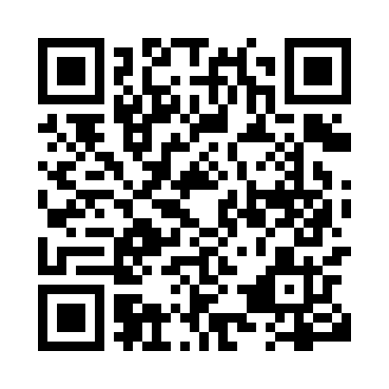
Prayer times for Ehkuapustet, Quebec, Canada
Mon 1 Jul 2024 - Wed 31 Jul 2024
High Latitude Method: Angle Based Rule
Prayer Calculation Method: Islamic Society of North America
Asar Calculation Method: Hanafi

Date | Day | Fajr | Sunrise | Dhuhr | Asr | Maghrib | Isha
1 | Mon | 2:14 | 4:07 | 12:20 | 5:55 | 8:33 | 10:27
2 | Tue | 2:14 | 4:08 | 12:20 | 5:55 | 8:33 | 10:27
3 | Wed | 2:15 | 4:09 | 12:21 | 5:55 | 8:32 | 10:26
4 | Thu | 2:15 | 4:10 | 12:21 | 5:54 | 8:32 | 10:26
5 | Fri | 2:16 | 4:10 | 12:21 | 5:54 | 8:31 | 10:26
6 | Sat | 2:16 | 4:11 | 12:21 | 5:54 | 8:31 | 10:26
7 | Sun | 2:17 | 4:12 | 12:21 | 5:54 | 8:30 | 10:26
8 | Mon | 2:17 | 4:13 | 12:21 | 5:54 | 8:29 | 10:25
9 | Tue | 2:18 | 4:14 | 12:22 | 5:53 | 8:29 | 10:25
10 | Wed | 2:18 | 4:15 | 12:22 | 5:53 | 8:28 | 10:25
11 | Thu | 2:19 | 4:16 | 12:22 | 5:53 | 8:27 | 10:24
12 | Fri | 2:19 | 4:17 | 12:22 | 5:52 | 8:26 | 10:24
13 | Sat | 2:20 | 4:18 | 12:22 | 5:52 | 8:25 | 10:24
14 | Sun | 2:21 | 4:19 | 12:22 | 5:51 | 8:25 | 10:23
15 | Mon | 2:21 | 4:21 | 12:22 | 5:51 | 8:24 | 10:23
16 | Tue | 2:22 | 4:22 | 12:22 | 5:50 | 8:23 | 10:22
17 | Wed | 2:23 | 4:23 | 12:23 | 5:50 | 8:21 | 10:22
18 | Thu | 2:23 | 4:24 | 12:23 | 5:49 | 8:20 | 10:21
19 | Fri | 2:24 | 4:25 | 12:23 | 5:49 | 8:19 | 10:21
20 | Sat | 2:25 | 4:27 | 12:23 | 5:48 | 8:18 | 10:20
21 | Sun | 2:25 | 4:28 | 12:23 | 5:47 | 8:17 | 10:20
22 | Mon | 2:26 | 4:29 | 12:23 | 5:47 | 8:16 | 10:19
23 | Tue | 2:27 | 4:31 | 12:23 | 5:46 | 8:14 | 10:18
24 | Wed | 2:27 | 4:32 | 12:23 | 5:45 | 8:13 | 10:18
25 | Thu | 2:28 | 4:33 | 12:23 | 5:44 | 8:12 | 10:17
26 | Fri | 2:29 | 4:35 | 12:23 | 5:43 | 8:10 | 10:16
27 | Sat | 2:29 | 4:36 | 12:23 | 5:43 | 8:09 | 10:16
28 | Sun | 2:30 | 4:38 | 12:23 | 5:42 | 8:07 | 10:15
29 | Mon | 2:32 | 4:39 | 12:23 | 5:41 | 8:06 | 10:12
30 | Tue | 2:34 | 4:40 | 12:23 | 5:40 | 8:04 | 10:10
31 | Wed | 2:37 | 4:42 | 12:23 | 5:39 | 8:03 | 10:07
Prayer times provided by https://www.salahtimes.com

