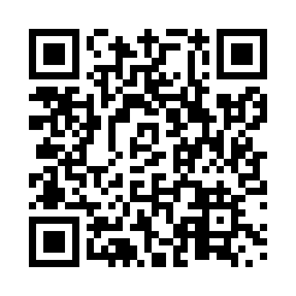
Prayer times for Chevery, Quebec, Canada
Wed 1 May 2024 - Fri 31 May 2024
High Latitude Method: Angle Based Rule
Prayer Calculation Method: Islamic Society of North America
Asar Calculation Method: Hanafi

Date | Day | Fajr | Sunrise | Dhuhr | Asr | Maghrib | Isha
1 | Wed | 2:40 | 4:32 | 11:55 | 5:02 | 7:19 | 9:12
2 | Thu | 2:38 | 4:31 | 11:55 | 5:03 | 7:21 | 9:15
3 | Fri | 2:35 | 4:29 | 11:55 | 5:04 | 7:23 | 9:17
4 | Sat | 2:32 | 4:27 | 11:55 | 5:05 | 7:24 | 9:20
5 | Sun | 2:30 | 4:25 | 11:55 | 5:06 | 7:26 | 9:22
6 | Mon | 2:27 | 4:24 | 11:55 | 5:06 | 7:27 | 9:25
7 | Tue | 2:24 | 4:22 | 11:55 | 5:07 | 7:29 | 9:27
8 | Wed | 2:22 | 4:20 | 11:55 | 5:08 | 7:30 | 9:30
9 | Thu | 2:19 | 4:19 | 11:55 | 5:09 | 7:32 | 9:32
10 | Fri | 2:16 | 4:17 | 11:55 | 5:10 | 7:33 | 9:35
11 | Sat | 2:14 | 4:16 | 11:55 | 5:11 | 7:35 | 9:38
12 | Sun | 2:11 | 4:14 | 11:55 | 5:12 | 7:36 | 9:40
13 | Mon | 2:08 | 4:13 | 11:55 | 5:13 | 7:38 | 9:43
14 | Tue | 2:06 | 4:11 | 11:55 | 5:14 | 7:39 | 9:46
15 | Wed | 2:03 | 4:10 | 11:55 | 5:14 | 7:41 | 9:48
16 | Thu | 2:02 | 4:09 | 11:55 | 5:15 | 7:42 | 9:49
17 | Fri | 2:01 | 4:07 | 11:55 | 5:16 | 7:43 | 9:49
18 | Sat | 2:01 | 4:06 | 11:55 | 5:17 | 7:45 | 9:50
19 | Sun | 2:00 | 4:05 | 11:55 | 5:18 | 7:46 | 9:51
20 | Mon | 1:59 | 4:03 | 11:55 | 5:19 | 7:47 | 9:51
21 | Tue | 1:59 | 4:02 | 11:55 | 5:19 | 7:49 | 9:52
22 | Wed | 1:58 | 4:01 | 11:55 | 5:20 | 7:50 | 9:53
23 | Thu | 1:58 | 4:00 | 11:55 | 5:21 | 7:51 | 9:53
24 | Fri | 1:57 | 3:59 | 11:55 | 5:22 | 7:53 | 9:54
25 | Sat | 1:57 | 3:58 | 11:55 | 5:22 | 7:54 | 9:55
26 | Sun | 1:56 | 3:57 | 11:56 | 5:23 | 7:55 | 9:55
27 | Mon | 1:56 | 3:56 | 11:56 | 5:24 | 7:56 | 9:56
28 | Tue | 1:55 | 3:55 | 11:56 | 5:24 | 7:57 | 9:57
29 | Wed | 1:55 | 3:54 | 11:56 | 5:25 | 7:58 | 9:57
30 | Thu | 1:55 | 3:53 | 11:56 | 5:26 | 8:00 | 9:58
31 | Fri | 1:54 | 3:52 | 11:56 | 5:26 | 8:01 | 9:59
Prayer times provided by https://www.salahtimes.com

