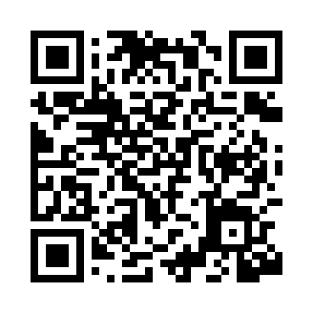
Prayer times for Mehrnbach, Austria
Wed 1 May 2024 - Fri 31 May 2024
High Latitude Method: Angle Based Rule
Prayer Calculation Method: Muslim World League
Asar Calculation Method: Shafi

Date | Day | Fajr | Sunrise | Dhuhr | Asr | Maghrib | Isha
1 | Wed | 3:37 | 5:47 | 1:03 | 5:03 | 8:20 | 10:22
2 | Thu | 3:34 | 5:45 | 1:03 | 5:04 | 8:22 | 10:24
3 | Fri | 3:31 | 5:44 | 1:03 | 5:04 | 8:23 | 10:27
4 | Sat | 3:29 | 5:42 | 1:03 | 5:05 | 8:25 | 10:29
5 | Sun | 3:26 | 5:41 | 1:03 | 5:05 | 8:26 | 10:32
6 | Mon | 3:23 | 5:39 | 1:03 | 5:06 | 8:27 | 10:34
7 | Tue | 3:20 | 5:38 | 1:03 | 5:06 | 8:29 | 10:36
8 | Wed | 3:18 | 5:36 | 1:03 | 5:07 | 8:30 | 10:39
9 | Thu | 3:15 | 5:35 | 1:03 | 5:07 | 8:32 | 10:41
10 | Fri | 3:12 | 5:33 | 1:03 | 5:08 | 8:33 | 10:44
11 | Sat | 3:09 | 5:32 | 1:03 | 5:08 | 8:34 | 10:46
12 | Sun | 3:07 | 5:30 | 1:03 | 5:09 | 8:36 | 10:49
13 | Mon | 3:04 | 5:29 | 1:03 | 5:09 | 8:37 | 10:51
14 | Tue | 3:01 | 5:28 | 1:03 | 5:10 | 8:38 | 10:54
15 | Wed | 2:59 | 5:26 | 1:03 | 5:10 | 8:40 | 10:56
16 | Thu | 2:56 | 5:25 | 1:03 | 5:11 | 8:41 | 10:59
17 | Fri | 2:53 | 5:24 | 1:03 | 5:11 | 8:42 | 11:01
18 | Sat | 2:50 | 5:23 | 1:03 | 5:12 | 8:43 | 11:04
19 | Sun | 2:48 | 5:22 | 1:03 | 5:12 | 8:45 | 11:06
20 | Mon | 2:46 | 5:20 | 1:03 | 5:13 | 8:46 | 11:09
21 | Tue | 2:46 | 5:19 | 1:03 | 5:13 | 8:47 | 11:11
22 | Wed | 2:45 | 5:18 | 1:03 | 5:13 | 8:48 | 11:13
23 | Thu | 2:45 | 5:17 | 1:03 | 5:14 | 8:49 | 11:13
24 | Fri | 2:45 | 5:16 | 1:03 | 5:14 | 8:51 | 11:14
25 | Sat | 2:44 | 5:15 | 1:03 | 5:15 | 8:52 | 11:14
26 | Sun | 2:44 | 5:14 | 1:03 | 5:15 | 8:53 | 11:15
27 | Mon | 2:44 | 5:14 | 1:03 | 5:16 | 8:54 | 11:15
28 | Tue | 2:43 | 5:13 | 1:04 | 5:16 | 8:55 | 11:16
29 | Wed | 2:43 | 5:12 | 1:04 | 5:17 | 8:56 | 11:17
30 | Thu | 2:43 | 5:11 | 1:04 | 5:17 | 8:57 | 11:17
31 | Fri | 2:43 | 5:11 | 1:04 | 5:17 | 8:58 | 11:18
Prayer times provided by https://www.salahtimes.com

