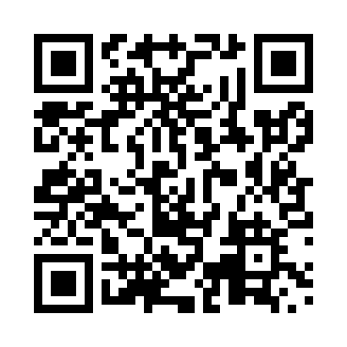
Prayer times for Tor Bay, Nova Scotia, Canada
Mon 1 Apr 2024 - Tue 30 Apr 2024
High Latitude Method: Angle Based Rule
Prayer Calculation Method: Islamic Society of North America
Asar Calculation Method: Hanafi

Date | Day | Fajr | Sunrise | Dhuhr | Asr | Maghrib | Isha
1 | Mon | 5:21 | 6:45 | 1:09 | 5:38 | 7:34 | 8:58
2 | Tue | 5:19 | 6:43 | 1:09 | 5:39 | 7:35 | 8:59
3 | Wed | 5:17 | 6:41 | 1:09 | 5:40 | 7:37 | 9:01
4 | Thu | 5:15 | 6:39 | 1:08 | 5:41 | 7:38 | 9:02
5 | Fri | 5:13 | 6:38 | 1:08 | 5:42 | 7:39 | 9:04
6 | Sat | 5:11 | 6:36 | 1:08 | 5:43 | 7:40 | 9:05
7 | Sun | 5:09 | 6:34 | 1:07 | 5:44 | 7:42 | 9:07
8 | Mon | 5:07 | 6:32 | 1:07 | 5:45 | 7:43 | 9:09
9 | Tue | 5:05 | 6:30 | 1:07 | 5:45 | 7:44 | 9:10
10 | Wed | 5:02 | 6:28 | 1:07 | 5:46 | 7:46 | 9:12
11 | Thu | 5:00 | 6:27 | 1:06 | 5:47 | 7:47 | 9:13
12 | Fri | 4:58 | 6:25 | 1:06 | 5:48 | 7:48 | 9:15
13 | Sat | 4:56 | 6:23 | 1:06 | 5:49 | 7:49 | 9:17
14 | Sun | 4:54 | 6:21 | 1:06 | 5:50 | 7:51 | 9:18
15 | Mon | 4:52 | 6:20 | 1:05 | 5:51 | 7:52 | 9:20
16 | Tue | 4:50 | 6:18 | 1:05 | 5:51 | 7:53 | 9:22
17 | Wed | 4:48 | 6:16 | 1:05 | 5:52 | 7:54 | 9:23
18 | Thu | 4:45 | 6:14 | 1:05 | 5:53 | 7:56 | 9:25
19 | Fri | 4:43 | 6:13 | 1:04 | 5:54 | 7:57 | 9:27
20 | Sat | 4:41 | 6:11 | 1:04 | 5:55 | 7:58 | 9:28
21 | Sun | 4:39 | 6:09 | 1:04 | 5:55 | 8:00 | 9:30
22 | Mon | 4:37 | 6:08 | 1:04 | 5:56 | 8:01 | 9:32
23 | Tue | 4:35 | 6:06 | 1:04 | 5:57 | 8:02 | 9:33
24 | Wed | 4:33 | 6:04 | 1:03 | 5:58 | 8:03 | 9:35
25 | Thu | 4:31 | 6:03 | 1:03 | 5:58 | 8:05 | 9:37
26 | Fri | 4:29 | 6:01 | 1:03 | 5:59 | 8:06 | 9:39
27 | Sat | 4:27 | 6:00 | 1:03 | 6:00 | 8:07 | 9:40
28 | Sun | 4:25 | 5:58 | 1:03 | 6:01 | 8:08 | 9:42
29 | Mon | 4:23 | 5:56 | 1:03 | 6:02 | 8:10 | 9:44
30 | Tue | 4:21 | 5:55 | 1:03 | 6:02 | 8:11 | 9:46
Prayer times provided by https://www.salahtimes.com

