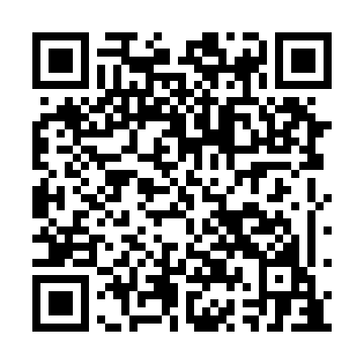
Prayer times for Goobies Station, Newfoundland and Labrador, Canada
Wed 1 May 2024 - Fri 31 May 2024
High Latitude Method: Angle Based Rule
Prayer Calculation Method: Islamic Society of North America
Asar Calculation Method: Hanafi

Date | Day | Fajr | Sunrise | Dhuhr | Asr | Maghrib | Isha
1 | Wed | 4:04 | 5:47 | 1:03 | 6:06 | 8:19 | 10:03
2 | Thu | 4:02 | 5:45 | 1:03 | 6:07 | 8:21 | 10:05
3 | Fri | 4:00 | 5:44 | 1:03 | 6:08 | 8:22 | 10:07
4 | Sat | 3:57 | 5:42 | 1:03 | 6:09 | 8:24 | 10:09
5 | Sun | 3:55 | 5:41 | 1:02 | 6:10 | 8:25 | 10:11
6 | Mon | 3:53 | 5:39 | 1:02 | 6:11 | 8:26 | 10:13
7 | Tue | 3:51 | 5:38 | 1:02 | 6:11 | 8:28 | 10:15
8 | Wed | 3:48 | 5:36 | 1:02 | 6:12 | 8:29 | 10:17
9 | Thu | 3:46 | 5:35 | 1:02 | 6:13 | 8:30 | 10:19
10 | Fri | 3:44 | 5:33 | 1:02 | 6:14 | 8:32 | 10:22
11 | Sat | 3:42 | 5:32 | 1:02 | 6:15 | 8:33 | 10:24
12 | Sun | 3:40 | 5:31 | 1:02 | 6:15 | 8:34 | 10:26
13 | Mon | 3:38 | 5:29 | 1:02 | 6:16 | 8:36 | 10:28
14 | Tue | 3:35 | 5:28 | 1:02 | 6:17 | 8:37 | 10:30
15 | Wed | 3:33 | 5:27 | 1:02 | 6:18 | 8:38 | 10:32
16 | Thu | 3:31 | 5:25 | 1:02 | 6:18 | 8:40 | 10:34
17 | Fri | 3:29 | 5:24 | 1:02 | 6:19 | 8:41 | 10:36
18 | Sat | 3:27 | 5:23 | 1:02 | 6:20 | 8:42 | 10:38
19 | Sun | 3:25 | 5:22 | 1:02 | 6:21 | 8:43 | 10:40
20 | Mon | 3:23 | 5:21 | 1:02 | 6:21 | 8:45 | 10:43
21 | Tue | 3:21 | 5:20 | 1:02 | 6:22 | 8:46 | 10:45
22 | Wed | 3:20 | 5:19 | 1:03 | 6:23 | 8:47 | 10:47
23 | Thu | 3:18 | 5:18 | 1:03 | 6:23 | 8:48 | 10:49
24 | Fri | 3:16 | 5:17 | 1:03 | 6:24 | 8:49 | 10:51
25 | Sat | 3:14 | 5:16 | 1:03 | 6:25 | 8:50 | 10:53
26 | Sun | 3:12 | 5:15 | 1:03 | 6:25 | 8:51 | 10:54
27 | Mon | 3:11 | 5:14 | 1:03 | 6:26 | 8:52 | 10:56
28 | Tue | 3:09 | 5:13 | 1:03 | 6:27 | 8:53 | 10:58
29 | Wed | 3:08 | 5:13 | 1:03 | 6:27 | 8:55 | 10:59
30 | Thu | 3:08 | 5:12 | 1:03 | 6:28 | 8:55 | 11:00
31 | Fri | 3:07 | 5:11 | 1:04 | 6:29 | 8:56 | 11:00
Prayer times provided by https://www.salahtimes.com

