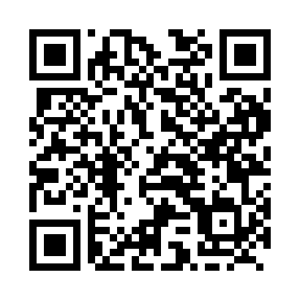
Prayer times for Silver Islet, Ontario, Canada
Mon 1 Jul 2024 - Wed 31 Jul 2024
High Latitude Method: Angle Based Rule
Prayer Calculation Method: Islamic Society of North America
Asar Calculation Method: Hanafi

Date | Day | Fajr | Sunrise | Dhuhr | Asr | Maghrib | Isha
1 | Mon | 3:59 | 5:59 | 1:59 | 7:28 | 10:00 | 11:59
2 | Tue | 3:59 | 5:59 | 2:00 | 7:28 | 9:59 | 11:59
3 | Wed | 4:00 | 6:00 | 2:00 | 7:28 | 9:59 | 11:59
4 | Thu | 4:00 | 6:01 | 2:00 | 7:28 | 9:59 | 11:59
5 | Fri | 4:01 | 6:02 | 2:00 | 7:28 | 9:58 | 11:59
6 | Sat | 4:01 | 6:02 | 2:00 | 7:28 | 9:58 | 11:59
7 | Sun | 4:02 | 6:03 | 2:00 | 7:27 | 9:57 | 11:59
8 | Mon | 4:02 | 6:04 | 2:01 | 7:27 | 9:57 | 11:58
9 | Tue | 4:03 | 6:05 | 2:01 | 7:27 | 9:56 | 11:58
10 | Wed | 4:03 | 6:06 | 2:01 | 7:27 | 9:55 | 11:58
11 | Thu | 4:04 | 6:07 | 2:01 | 7:26 | 9:55 | 11:58
12 | Fri | 4:04 | 6:08 | 2:01 | 7:26 | 9:54 | 11:57
13 | Sat | 4:05 | 6:09 | 2:01 | 7:26 | 9:53 | 11:57
14 | Sun | 4:05 | 6:10 | 2:01 | 7:25 | 9:52 | 11:57
15 | Mon | 4:06 | 6:11 | 2:01 | 7:25 | 9:51 | 11:56
16 | Tue | 4:07 | 6:12 | 2:01 | 7:24 | 9:51 | 11:55
17 | Wed | 4:09 | 6:13 | 2:02 | 7:24 | 9:50 | 11:53
18 | Thu | 4:11 | 6:14 | 2:02 | 7:23 | 9:49 | 11:51
19 | Fri | 4:13 | 6:15 | 2:02 | 7:23 | 9:48 | 11:50
20 | Sat | 4:15 | 6:16 | 2:02 | 7:22 | 9:47 | 11:48
21 | Sun | 4:17 | 6:18 | 2:02 | 7:22 | 9:45 | 11:46
22 | Mon | 4:19 | 6:19 | 2:02 | 7:21 | 9:44 | 11:44
23 | Tue | 4:21 | 6:20 | 2:02 | 7:20 | 9:43 | 11:41
24 | Wed | 4:23 | 6:21 | 2:02 | 7:20 | 9:42 | 11:39
25 | Thu | 4:25 | 6:22 | 2:02 | 7:19 | 9:41 | 11:37
26 | Fri | 4:27 | 6:24 | 2:02 | 7:18 | 9:39 | 11:35
27 | Sat | 4:29 | 6:25 | 2:02 | 7:18 | 9:38 | 11:33
28 | Sun | 4:32 | 6:26 | 2:02 | 7:17 | 9:37 | 11:31
29 | Mon | 4:34 | 6:27 | 2:02 | 7:16 | 9:35 | 11:29
30 | Tue | 4:36 | 6:29 | 2:02 | 7:15 | 9:34 | 11:26
31 | Wed | 4:38 | 6:30 | 2:02 | 7:14 | 9:33 | 11:24
Prayer times provided by https://www.salahtimes.com

