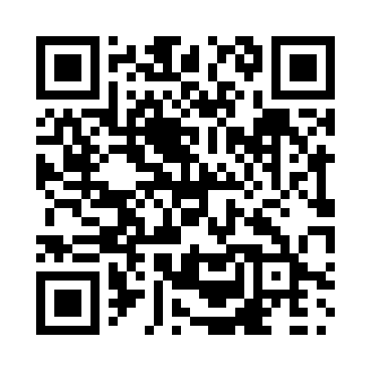
Prayer times for Antonio, Alberta, Canada
Mon 1 Apr 2024 - Tue 30 Apr 2024
High Latitude Method: Angle Based Rule
Prayer Calculation Method: Islamic Society of North America
Asar Calculation Method: Hanafi

Date | Day | Fajr | Sunrise | Dhuhr | Asr | Maghrib | Isha
1 | Mon | 5:30 | 7:03 | 1:31 | 5:59 | 8:00 | 9:33
2 | Tue | 5:28 | 7:00 | 1:31 | 6:00 | 8:02 | 9:35
3 | Wed | 5:25 | 6:58 | 1:30 | 6:01 | 8:03 | 9:37
4 | Thu | 5:23 | 6:56 | 1:30 | 6:02 | 8:05 | 9:38
5 | Fri | 5:20 | 6:54 | 1:30 | 6:04 | 8:06 | 9:40
6 | Sat | 5:18 | 6:52 | 1:29 | 6:05 | 8:08 | 9:42
7 | Sun | 5:15 | 6:50 | 1:29 | 6:06 | 8:09 | 9:44
8 | Mon | 5:13 | 6:48 | 1:29 | 6:07 | 8:11 | 9:46
9 | Tue | 5:10 | 6:46 | 1:29 | 6:08 | 8:12 | 9:48
10 | Wed | 5:07 | 6:43 | 1:28 | 6:09 | 8:14 | 9:50
11 | Thu | 5:05 | 6:41 | 1:28 | 6:10 | 8:16 | 9:52
12 | Fri | 5:02 | 6:39 | 1:28 | 6:11 | 8:17 | 9:54
13 | Sat | 5:00 | 6:37 | 1:28 | 6:12 | 8:19 | 9:57
14 | Sun | 4:57 | 6:35 | 1:27 | 6:13 | 8:20 | 9:59
15 | Mon | 4:55 | 6:33 | 1:27 | 6:14 | 8:22 | 10:01
16 | Tue | 4:52 | 6:31 | 1:27 | 6:15 | 8:23 | 10:03
17 | Wed | 4:49 | 6:29 | 1:27 | 6:16 | 8:25 | 10:05
18 | Thu | 4:47 | 6:27 | 1:26 | 6:17 | 8:26 | 10:07
19 | Fri | 4:44 | 6:25 | 1:26 | 6:18 | 8:28 | 10:09
20 | Sat | 4:42 | 6:23 | 1:26 | 6:19 | 8:30 | 10:11
21 | Sun | 4:39 | 6:21 | 1:26 | 6:20 | 8:31 | 10:14
22 | Mon | 4:37 | 6:19 | 1:26 | 6:21 | 8:33 | 10:16
23 | Tue | 4:34 | 6:17 | 1:25 | 6:22 | 8:34 | 10:18
24 | Wed | 4:31 | 6:16 | 1:25 | 6:23 | 8:36 | 10:20
25 | Thu | 4:29 | 6:14 | 1:25 | 6:24 | 8:37 | 10:23
26 | Fri | 4:26 | 6:12 | 1:25 | 6:25 | 8:39 | 10:25
27 | Sat | 4:24 | 6:10 | 1:25 | 6:26 | 8:40 | 10:27
28 | Sun | 4:21 | 6:08 | 1:25 | 6:27 | 8:42 | 10:30
29 | Mon | 4:18 | 6:06 | 1:24 | 6:28 | 8:43 | 10:32
30 | Tue | 4:16 | 6:05 | 1:24 | 6:29 | 8:45 | 10:34
Prayer times provided by https://www.salahtimes.com

