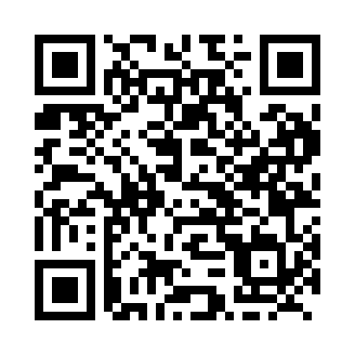
Prayer times for Corner Brook, Newfoundland and Labrador, Canada
Wed 1 May 2024 - Fri 31 May 2024
High Latitude Method: Angle Based Rule
Prayer Calculation Method: Islamic Society of North America
Asar Calculation Method: Hanafi

Date | Day | Fajr | Sunrise | Dhuhr | Asr | Maghrib | Isha
1 | Wed | 4:14 | 6:00 | 1:19 | 6:24 | 8:38 | 10:25
2 | Thu | 4:12 | 5:59 | 1:19 | 6:24 | 8:40 | 10:27
3 | Fri | 4:09 | 5:57 | 1:19 | 6:25 | 8:41 | 10:29
4 | Sat | 4:07 | 5:55 | 1:19 | 6:26 | 8:43 | 10:32
5 | Sun | 4:04 | 5:54 | 1:19 | 6:27 | 8:44 | 10:34
6 | Mon | 4:02 | 5:52 | 1:18 | 6:28 | 8:46 | 10:36
7 | Tue | 4:00 | 5:51 | 1:18 | 6:29 | 8:47 | 10:39
8 | Wed | 3:57 | 5:49 | 1:18 | 6:30 | 8:48 | 10:41
9 | Thu | 3:55 | 5:47 | 1:18 | 6:30 | 8:50 | 10:43
10 | Fri | 3:52 | 5:46 | 1:18 | 6:31 | 8:51 | 10:45
11 | Sat | 3:50 | 5:45 | 1:18 | 6:32 | 8:53 | 10:48
12 | Sun | 3:48 | 5:43 | 1:18 | 6:33 | 8:54 | 10:50
13 | Mon | 3:45 | 5:42 | 1:18 | 6:34 | 8:55 | 10:52
14 | Tue | 3:43 | 5:40 | 1:18 | 6:35 | 8:57 | 10:55
15 | Wed | 3:41 | 5:39 | 1:18 | 6:35 | 8:58 | 10:57
16 | Thu | 3:39 | 5:38 | 1:18 | 6:36 | 8:59 | 10:59
17 | Fri | 3:36 | 5:37 | 1:18 | 6:37 | 9:01 | 11:01
18 | Sat | 3:34 | 5:35 | 1:18 | 6:38 | 9:02 | 11:04
19 | Sun | 3:32 | 5:34 | 1:18 | 6:38 | 9:03 | 11:06
20 | Mon | 3:30 | 5:33 | 1:18 | 6:39 | 9:05 | 11:08
21 | Tue | 3:28 | 5:32 | 1:19 | 6:40 | 9:06 | 11:10
22 | Wed | 3:26 | 5:31 | 1:19 | 6:41 | 9:07 | 11:13
23 | Thu | 3:24 | 5:30 | 1:19 | 6:41 | 9:08 | 11:14
24 | Fri | 3:24 | 5:29 | 1:19 | 6:42 | 9:09 | 11:14
25 | Sat | 3:23 | 5:28 | 1:19 | 6:43 | 9:11 | 11:15
26 | Sun | 3:23 | 5:27 | 1:19 | 6:43 | 9:12 | 11:15
27 | Mon | 3:23 | 5:26 | 1:19 | 6:44 | 9:13 | 11:16
28 | Tue | 3:22 | 5:25 | 1:19 | 6:45 | 9:14 | 11:17
29 | Wed | 3:22 | 5:24 | 1:19 | 6:45 | 9:15 | 11:17
30 | Thu | 3:22 | 5:24 | 1:20 | 6:46 | 9:16 | 11:18
31 | Fri | 3:21 | 5:23 | 1:20 | 6:47 | 9:17 | 11:18
Prayer times provided by https://www.salahtimes.com

