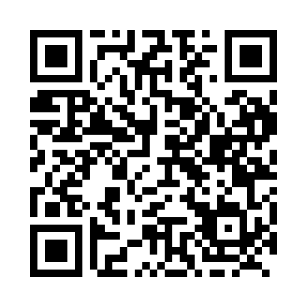

**Prayer times for Purtuniq, Quebec, Canada**

**Sun 1 Sep 2024 - Mon 30 Sep 2024**

**High Latitude Method: Angle Based Rule**

**Prayer Calculation Method: Islamic Society of North America**

**Asar Calculation Method: Hanafi**

|  |  |  |  |  |  |  |  |
| --- | --- | --- | --- | --- | --- | --- | --- |
| **Date** | **Day** | **Fajr** | **Sunrise** | **Dhuhr** | **Asr** | **Maghrib** | **Isha** |
| 1 | Sun | 3:21 | 5:47 | 12:56 | 5:34 | 8:02 | 10:29 |
| 2 | Mon | 3:22 | 5:50 | 12:55 | 5:32 | 7:59 | 10:27 |
| 3 | Tue | 3:26 | 5:53 | 12:55 | 5:29 | 7:56 | 10:22 |
| 4 | Wed | 3:30 | 5:55 | 12:55 | 5:27 | 7:53 | 10:17 |
| 5 | Thu | 3:34 | 5:58 | 12:54 | 5:24 | 7:49 | 10:12 |
| 6 | Fri | 3:39 | 6:00 | 12:54 | 5:22 | 7:46 | 10:07 |
| 7 | Sat | 3:43 | 6:03 | 12:54 | 5:19 | 7:43 | 10:02 |
| 8 | Sun | 3:47 | 6:05 | 12:53 | 5:17 | 7:40 | 9:58 |
| 9 | Mon | 3:50 | 6:08 | 12:53 | 5:14 | 7:36 | 9:53 |
| 10 | Tue | 3:54 | 6:10 | 12:53 | 5:11 | 7:33 | 9:49 |
| 11 | Wed | 3:58 | 6:13 | 12:52 | 5:09 | 7:30 | 9:44 |
| 12 | Thu | 4:02 | 6:16 | 12:52 | 5:06 | 7:27 | 9:40 |
| 13 | Fri | 4:05 | 6:18 | 12:51 | 5:04 | 7:23 | 9:36 |
| 14 | Sat | 4:09 | 6:21 | 12:51 | 5:01 | 7:20 | 9:32 |
| 15 | Sun | 4:12 | 6:23 | 12:51 | 4:58 | 7:17 | 9:27 |
| 16 | Mon | 4:16 | 6:26 | 12:50 | 4:56 | 7:14 | 9:23 |
| 17 | Tue | 4:19 | 6:28 | 12:50 | 4:53 | 7:10 | 9:19 |
| 18 | Wed | 4:22 | 6:31 | 12:50 | 4:50 | 7:07 | 9:15 |
| 19 | Thu | 4:25 | 6:33 | 12:49 | 4:48 | 7:04 | 9:11 |
| 20 | Fri | 4:29 | 6:36 | 12:49 | 4:45 | 7:01 | 9:07 |
| 21 | Sat | 4:32 | 6:39 | 12:49 | 4:42 | 6:57 | 9:03 |
| 22 | Sun | 4:35 | 6:41 | 12:48 | 4:40 | 6:54 | 9:00 |
| 23 | Mon | 4:38 | 6:44 | 12:48 | 4:37 | 6:51 | 8:56 |
| 24 | Tue | 4:41 | 6:46 | 12:48 | 4:34 | 6:47 | 8:52 |
| 25 | Wed | 4:44 | 6:49 | 12:47 | 4:31 | 6:44 | 8:48 |
| 26 | Thu | 4:47 | 6:51 | 12:47 | 4:29 | 6:41 | 8:45 |
| 27 | Fri | 4:50 | 6:54 | 12:47 | 4:26 | 6:38 | 8:41 |
| 28 | Sat | 4:53 | 6:56 | 12:46 | 4:23 | 6:34 | 8:37 |
| 29 | Sun | 4:56 | 6:59 | 12:46 | 4:20 | 6:31 | 8:34 |
| 30 | Mon | 4:59 | 7:02 | 12:46 | 4:18 | 6:28 | 8:30 |

**Prayer times provided by https://www.salahtimes.com**