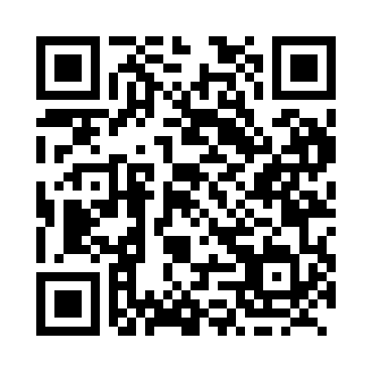
Prayer times for Allensville, Ontario, Canada
Wed 1 May 2024 - Fri 31 May 2024
High Latitude Method: Angle Based Rule
Prayer Calculation Method: Islamic Society of North America
Asar Calculation Method: Hanafi

Date | Day | Fajr | Sunrise | Dhuhr | Asr | Maghrib | Isha
1 | Wed | 4:30 | 6:05 | 1:14 | 6:15 | 8:24 | 10:00
2 | Thu | 4:28 | 6:04 | 1:14 | 6:16 | 8:25 | 10:01
3 | Fri | 4:26 | 6:02 | 1:14 | 6:16 | 8:27 | 10:03
4 | Sat | 4:24 | 6:01 | 1:14 | 6:17 | 8:28 | 10:05
5 | Sun | 4:22 | 5:59 | 1:14 | 6:18 | 8:29 | 10:07
6 | Mon | 4:20 | 5:58 | 1:14 | 6:19 | 8:30 | 10:08
7 | Tue | 4:18 | 5:57 | 1:14 | 6:19 | 8:32 | 10:10
8 | Wed | 4:16 | 5:55 | 1:14 | 6:20 | 8:33 | 10:12
9 | Thu | 4:14 | 5:54 | 1:14 | 6:21 | 8:34 | 10:14
10 | Fri | 4:13 | 5:53 | 1:14 | 6:22 | 8:35 | 10:16
11 | Sat | 4:11 | 5:51 | 1:14 | 6:22 | 8:36 | 10:17
12 | Sun | 4:09 | 5:50 | 1:14 | 6:23 | 8:38 | 10:19
13 | Mon | 4:07 | 5:49 | 1:14 | 6:24 | 8:39 | 10:21
14 | Tue | 4:05 | 5:48 | 1:14 | 6:24 | 8:40 | 10:23
15 | Wed | 4:04 | 5:47 | 1:14 | 6:25 | 8:41 | 10:24
16 | Thu | 4:02 | 5:46 | 1:14 | 6:26 | 8:42 | 10:26
17 | Fri | 4:00 | 5:45 | 1:14 | 6:26 | 8:43 | 10:28
18 | Sat | 3:59 | 5:43 | 1:14 | 6:27 | 8:44 | 10:30
19 | Sun | 3:57 | 5:42 | 1:14 | 6:28 | 8:46 | 10:31
20 | Mon | 3:55 | 5:41 | 1:14 | 6:28 | 8:47 | 10:33
21 | Tue | 3:54 | 5:41 | 1:14 | 6:29 | 8:48 | 10:35
22 | Wed | 3:52 | 5:40 | 1:14 | 6:30 | 8:49 | 10:36
23 | Thu | 3:51 | 5:39 | 1:14 | 6:30 | 8:50 | 10:38
24 | Fri | 3:49 | 5:38 | 1:14 | 6:31 | 8:51 | 10:40
25 | Sat | 3:48 | 5:37 | 1:14 | 6:31 | 8:52 | 10:41
26 | Sun | 3:47 | 5:36 | 1:14 | 6:32 | 8:53 | 10:43
27 | Mon | 3:45 | 5:36 | 1:14 | 6:33 | 8:54 | 10:44
28 | Tue | 3:44 | 5:35 | 1:15 | 6:33 | 8:55 | 10:46
29 | Wed | 3:43 | 5:34 | 1:15 | 6:34 | 8:56 | 10:47
30 | Thu | 3:42 | 5:34 | 1:15 | 6:34 | 8:57 | 10:49
31 | Fri | 3:41 | 5:33 | 1:15 | 6:35 | 8:57 | 10:50
Prayer times provided by https://www.salahtimes.com

