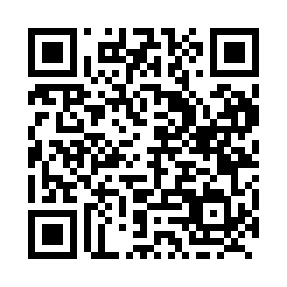
Prayer times for Bunessan, Ontario, Canada
Mon 1 Apr 2024 - Tue 30 Apr 2024
High Latitude Method: Angle Based Rule
Prayer Calculation Method: Islamic Society of North America
Asar Calculation Method: Hanafi

Date | Day | Fajr | Sunrise | Dhuhr | Asr | Maghrib | Isha
1 | Mon | 5:41 | 7:03 | 1:27 | 5:56 | 7:51 | 9:13
2 | Tue | 5:39 | 7:01 | 1:26 | 5:57 | 7:52 | 9:14
3 | Wed | 5:37 | 6:59 | 1:26 | 5:58 | 7:53 | 9:16
4 | Thu | 5:35 | 6:58 | 1:26 | 5:59 | 7:54 | 9:17
5 | Fri | 5:33 | 6:56 | 1:25 | 6:00 | 7:56 | 9:19
6 | Sat | 5:31 | 6:54 | 1:25 | 6:00 | 7:57 | 9:20
7 | Sun | 5:29 | 6:52 | 1:25 | 6:01 | 7:58 | 9:22
8 | Mon | 5:27 | 6:51 | 1:25 | 6:02 | 7:59 | 9:23
9 | Tue | 5:25 | 6:49 | 1:24 | 6:03 | 8:01 | 9:25
10 | Wed | 5:23 | 6:47 | 1:24 | 6:04 | 8:02 | 9:26
11 | Thu | 5:21 | 6:45 | 1:24 | 6:04 | 8:03 | 9:28
12 | Fri | 5:19 | 6:44 | 1:23 | 6:05 | 8:04 | 9:29
13 | Sat | 5:17 | 6:42 | 1:23 | 6:06 | 8:05 | 9:31
14 | Sun | 5:15 | 6:40 | 1:23 | 6:07 | 8:07 | 9:32
15 | Mon | 5:13 | 6:38 | 1:23 | 6:08 | 8:08 | 9:34
16 | Tue | 5:10 | 6:37 | 1:23 | 6:08 | 8:09 | 9:36
17 | Wed | 5:08 | 6:35 | 1:22 | 6:09 | 8:10 | 9:37
18 | Thu | 5:06 | 6:33 | 1:22 | 6:10 | 8:11 | 9:39
19 | Fri | 5:04 | 6:32 | 1:22 | 6:11 | 8:13 | 9:40
20 | Sat | 5:02 | 6:30 | 1:22 | 6:11 | 8:14 | 9:42
21 | Sun | 5:00 | 6:28 | 1:21 | 6:12 | 8:15 | 9:43
22 | Mon | 4:58 | 6:27 | 1:21 | 6:13 | 8:16 | 9:45
23 | Tue | 4:56 | 6:25 | 1:21 | 6:14 | 8:18 | 9:47
24 | Wed | 4:54 | 6:24 | 1:21 | 6:14 | 8:19 | 9:48
25 | Thu | 4:52 | 6:22 | 1:21 | 6:15 | 8:20 | 9:50
26 | Fri | 4:50 | 6:21 | 1:21 | 6:16 | 8:21 | 9:52
27 | Sat | 4:48 | 6:19 | 1:20 | 6:17 | 8:22 | 9:53
28 | Sun | 4:47 | 6:18 | 1:20 | 6:17 | 8:24 | 9:55
29 | Mon | 4:45 | 6:16 | 1:20 | 6:18 | 8:25 | 9:57
30 | Tue | 4:43 | 6:15 | 1:20 | 6:19 | 8:26 | 9:58
Prayer times provided by https://www.salahtimes.com

