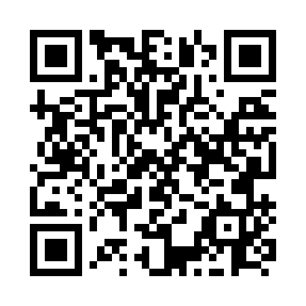

**Prayer times for Nuliarvik, Quebec, Canada**

**Wed 1 Jan 2025 - Fri 31 Jan 2025**

**High Latitude Method: Angle Based Rule**

**Prayer Calculation Method: Islamic Society of North America**

**Asar Calculation Method: Hanafi**

|  |  |  |  |  |  |  |  |
| --- | --- | --- | --- | --- | --- | --- | --- |
| **Date** | **Day** | **Fajr** | **Sunrise** | **Dhuhr** | **Asr** | **Maghrib** | **Isha** |
| 1 | Wed | 6:25 | 8:51 | 11:42 | 12:48 | 2:35 | 5:00 |
| 2 | Thu | 6:25 | 8:50 | 11:43 | 12:50 | 2:36 | 5:01 |
| 3 | Fri | 6:24 | 8:49 | 11:43 | 12:51 | 2:38 | 5:03 |
| 4 | Sat | 6:24 | 8:48 | 11:44 | 12:53 | 2:40 | 5:04 |
| 5 | Sun | 6:24 | 8:47 | 11:44 | 12:54 | 2:42 | 5:05 |
| 6 | Mon | 6:23 | 8:46 | 11:45 | 12:56 | 2:44 | 5:07 |
| 7 | Tue | 6:23 | 8:45 | 11:45 | 12:57 | 2:46 | 5:08 |
| 8 | Wed | 6:22 | 8:44 | 11:46 | 12:59 | 2:48 | 5:10 |
| 9 | Thu | 6:21 | 8:43 | 11:46 | 1:01 | 2:50 | 5:11 |
| 10 | Fri | 6:21 | 8:42 | 11:46 | 1:03 | 2:52 | 5:13 |
| 11 | Sat | 6:20 | 8:40 | 11:47 | 1:04 | 2:54 | 5:14 |
| 12 | Sun | 6:19 | 8:39 | 11:47 | 1:06 | 2:56 | 5:16 |
| 13 | Mon | 6:18 | 8:37 | 11:47 | 1:08 | 2:59 | 5:18 |
| 14 | Tue | 6:17 | 8:36 | 11:48 | 1:10 | 3:01 | 5:19 |
| 15 | Wed | 6:16 | 8:34 | 11:48 | 1:12 | 3:04 | 5:21 |
| 16 | Thu | 6:15 | 8:32 | 11:49 | 1:14 | 3:06 | 5:23 |
| 17 | Fri | 6:14 | 8:30 | 11:49 | 1:17 | 3:08 | 5:25 |
| 18 | Sat | 6:13 | 8:29 | 11:49 | 1:19 | 3:11 | 5:26 |
| 19 | Sun | 6:12 | 8:27 | 11:49 | 1:21 | 3:13 | 5:28 |
| 20 | Mon | 6:10 | 8:25 | 11:50 | 1:23 | 3:16 | 5:30 |
| 21 | Tue | 6:09 | 8:23 | 11:50 | 1:25 | 3:19 | 5:32 |
| 22 | Wed | 6:07 | 8:21 | 11:50 | 1:28 | 3:21 | 5:34 |
| 23 | Thu | 6:06 | 8:18 | 11:51 | 1:30 | 3:24 | 5:36 |
| 24 | Fri | 6:04 | 8:16 | 11:51 | 1:32 | 3:27 | 5:38 |
| 25 | Sat | 6:03 | 8:14 | 11:51 | 1:35 | 3:29 | 5:40 |
| 26 | Sun | 6:01 | 8:12 | 11:51 | 1:37 | 3:32 | 5:42 |
| 27 | Mon | 6:00 | 8:09 | 11:51 | 1:39 | 3:35 | 5:44 |
| 28 | Tue | 5:58 | 8:07 | 11:52 | 1:42 | 3:37 | 5:46 |
| 29 | Wed | 5:56 | 8:05 | 11:52 | 1:44 | 3:40 | 5:49 |
| 30 | Thu | 5:54 | 8:02 | 11:52 | 1:47 | 3:43 | 5:51 |
| 31 | Fri | 5:52 | 8:00 | 11:52 | 1:49 | 3:46 | 5:53 |

**Prayer times provided by https://www.salahtimes.com**