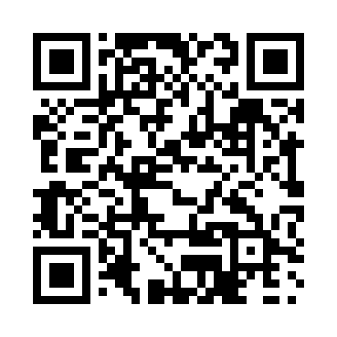
Prayer times for Blucher Hall, British Columbia, Canada
Wed 1 May 2024 - Fri 31 May 2024
High Latitude Method: Angle Based Rule
Prayer Calculation Method: Islamic Society of North America
Asar Calculation Method: Hanafi

Date | Day | Fajr | Sunrise | Dhuhr | Asr | Maghrib | Isha
1 | Wed | 3:37 | 5:32 | 12:57 | 6:04 | 8:23 | 10:19
2 | Thu | 3:34 | 5:30 | 12:57 | 6:05 | 8:25 | 10:21
3 | Fri | 3:31 | 5:28 | 12:57 | 6:06 | 8:26 | 10:24
4 | Sat | 3:28 | 5:26 | 12:57 | 6:07 | 8:28 | 10:27
5 | Sun | 3:26 | 5:25 | 12:57 | 6:08 | 8:30 | 10:29
6 | Mon | 3:23 | 5:23 | 12:57 | 6:09 | 8:31 | 10:32
7 | Tue | 3:20 | 5:21 | 12:57 | 6:10 | 8:33 | 10:35
8 | Wed | 3:17 | 5:20 | 12:57 | 6:11 | 8:34 | 10:38
9 | Thu | 3:14 | 5:18 | 12:56 | 6:12 | 8:36 | 10:40
10 | Fri | 3:11 | 5:16 | 12:56 | 6:13 | 8:37 | 10:43
11 | Sat | 3:09 | 5:15 | 12:56 | 6:14 | 8:39 | 10:46
12 | Sun | 3:06 | 5:13 | 12:56 | 6:15 | 8:40 | 10:49
13 | Mon | 3:04 | 5:12 | 12:56 | 6:15 | 8:42 | 10:49
14 | Tue | 3:03 | 5:10 | 12:56 | 6:16 | 8:43 | 10:50
15 | Wed | 3:03 | 5:09 | 12:56 | 6:17 | 8:45 | 10:51
16 | Thu | 3:02 | 5:07 | 12:56 | 6:18 | 8:46 | 10:52
17 | Fri | 3:01 | 5:06 | 12:57 | 6:19 | 8:48 | 10:52
18 | Sat | 3:01 | 5:05 | 12:57 | 6:20 | 8:49 | 10:53
19 | Sun | 3:00 | 5:03 | 12:57 | 6:21 | 8:51 | 10:54
20 | Mon | 3:00 | 5:02 | 12:57 | 6:21 | 8:52 | 10:54
21 | Tue | 2:59 | 5:01 | 12:57 | 6:22 | 8:53 | 10:55
22 | Wed | 2:58 | 5:00 | 12:57 | 6:23 | 8:55 | 10:56
23 | Thu | 2:58 | 4:58 | 12:57 | 6:24 | 8:56 | 10:57
24 | Fri | 2:57 | 4:57 | 12:57 | 6:25 | 8:57 | 10:57
25 | Sat | 2:57 | 4:56 | 12:57 | 6:25 | 8:59 | 10:58
26 | Sun | 2:56 | 4:55 | 12:57 | 6:26 | 9:00 | 10:59
27 | Mon | 2:56 | 4:54 | 12:57 | 6:27 | 9:01 | 10:59
28 | Tue | 2:56 | 4:53 | 12:57 | 6:27 | 9:02 | 11:00
29 | Wed | 2:55 | 4:52 | 12:58 | 6:28 | 9:03 | 11:01
30 | Thu | 2:55 | 4:52 | 12:58 | 6:29 | 9:04 | 11:01
31 | Fri | 2:54 | 4:51 | 12:58 | 6:29 | 9:05 | 11:02
Prayer times provided by https://www.salahtimes.com

