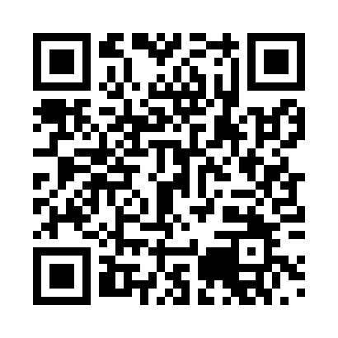

**Prayer times for Molschbach, Germany**

**Wed 1 Jan 2025 - Fri 31 Jan 2025**

**High Latitude Method: Angle Based Rule**

**Prayer Calculation Method: Muslim World League**

**Asar Calculation Method: Shafi**

|  |  |  |  |  |  |  |  |
| --- | --- | --- | --- | --- | --- | --- | --- |
| **Date** | **Day** | **Fajr** | **Sunrise** | **Dhuhr** | **Asr** | **Maghrib** | **Isha** |
| 1 | Wed | 6:27 | 8:24 | 12:32 | 2:23 | 4:41 | 6:31 |
| 2 | Thu | 6:27 | 8:24 | 12:33 | 2:24 | 4:42 | 6:32 |
| 3 | Fri | 6:27 | 8:24 | 12:33 | 2:25 | 4:43 | 6:33 |
| 4 | Sat | 6:27 | 8:24 | 12:34 | 2:26 | 4:44 | 6:34 |
| 5 | Sun | 6:27 | 8:24 | 12:34 | 2:27 | 4:45 | 6:35 |
| 6 | Mon | 6:27 | 8:24 | 12:35 | 2:28 | 4:46 | 6:36 |
| 7 | Tue | 6:27 | 8:23 | 12:35 | 2:29 | 4:47 | 6:37 |
| 8 | Wed | 6:27 | 8:23 | 12:36 | 2:30 | 4:49 | 6:38 |
| 9 | Thu | 6:27 | 8:22 | 12:36 | 2:31 | 4:50 | 6:39 |
| 10 | Fri | 6:26 | 8:22 | 12:36 | 2:32 | 4:51 | 6:40 |
| 11 | Sat | 6:26 | 8:21 | 12:37 | 2:34 | 4:53 | 6:41 |
| 12 | Sun | 6:26 | 8:21 | 12:37 | 2:35 | 4:54 | 6:43 |
| 13 | Mon | 6:25 | 8:20 | 12:37 | 2:36 | 4:55 | 6:44 |
| 14 | Tue | 6:25 | 8:20 | 12:38 | 2:37 | 4:57 | 6:45 |
| 15 | Wed | 6:24 | 8:19 | 12:38 | 2:38 | 4:58 | 6:46 |
| 16 | Thu | 6:24 | 8:18 | 12:39 | 2:40 | 5:00 | 6:47 |
| 17 | Fri | 6:23 | 8:17 | 12:39 | 2:41 | 5:01 | 6:49 |
| 18 | Sat | 6:23 | 8:16 | 12:39 | 2:42 | 5:03 | 6:50 |
| 19 | Sun | 6:22 | 8:15 | 12:39 | 2:43 | 5:04 | 6:51 |
| 20 | Mon | 6:21 | 8:15 | 12:40 | 2:45 | 5:06 | 6:52 |
| 21 | Tue | 6:21 | 8:14 | 12:40 | 2:46 | 5:07 | 6:54 |
| 22 | Wed | 6:20 | 8:13 | 12:40 | 2:47 | 5:09 | 6:55 |
| 23 | Thu | 6:19 | 8:11 | 12:41 | 2:49 | 5:10 | 6:56 |
| 24 | Fri | 6:18 | 8:10 | 12:41 | 2:50 | 5:12 | 6:58 |
| 25 | Sat | 6:17 | 8:09 | 12:41 | 2:51 | 5:14 | 6:59 |
| 26 | Sun | 6:17 | 8:08 | 12:41 | 2:53 | 5:15 | 7:00 |
| 27 | Mon | 6:16 | 8:07 | 12:41 | 2:54 | 5:17 | 7:02 |
| 28 | Tue | 6:15 | 8:06 | 12:42 | 2:55 | 5:19 | 7:03 |
| 29 | Wed | 6:14 | 8:04 | 12:42 | 2:57 | 5:20 | 7:05 |
| 30 | Thu | 6:13 | 8:03 | 12:42 | 2:58 | 5:22 | 7:06 |
| 31 | Fri | 6:11 | 8:02 | 12:42 | 2:59 | 5:23 | 7:07 |

**Prayer times provided by https://www.salahtimes.com**