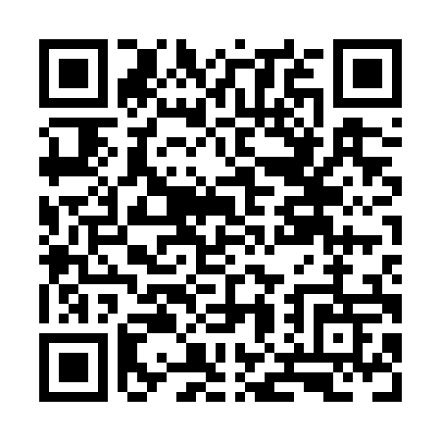
Prayer times for Yukon Crossing, Yukon, Canada
Wed 1 May 2024 - Fri 31 May 2024
High Latitude Method: Angle Based Rule
Prayer Calculation Method: Islamic Society of North America
Asar Calculation Method: Hanafi

Date | Day | Fajr | Sunrise | Dhuhr | Asr | Maghrib | Isha
1 | Wed | 3:56 | 5:48 | 2:03 | 7:25 | 10:20 | 12:12
2 | Thu | 3:54 | 5:45 | 2:03 | 7:26 | 10:23 | 12:13
3 | Fri | 3:53 | 5:42 | 2:03 | 7:28 | 10:25 | 12:14
4 | Sat | 3:51 | 5:39 | 2:03 | 7:30 | 10:28 | 12:16
5 | Sun | 3:49 | 5:36 | 2:03 | 7:31 | 10:31 | 12:17
6 | Mon | 3:48 | 5:33 | 2:03 | 7:33 | 10:34 | 12:19
7 | Tue | 3:46 | 5:30 | 2:02 | 7:34 | 10:37 | 12:20
8 | Wed | 3:45 | 5:27 | 2:02 | 7:36 | 10:40 | 12:21
9 | Thu | 3:43 | 5:24 | 2:02 | 7:37 | 10:42 | 12:23
10 | Fri | 3:42 | 5:21 | 2:02 | 7:39 | 10:45 | 12:24
11 | Sat | 3:41 | 5:18 | 2:02 | 7:40 | 10:48 | 12:26
12 | Sun | 3:39 | 5:15 | 2:02 | 7:42 | 10:51 | 12:27
13 | Mon | 3:38 | 5:12 | 2:02 | 7:43 | 10:54 | 12:28
14 | Tue | 3:36 | 5:10 | 2:02 | 7:44 | 10:56 | 12:30
15 | Wed | 3:35 | 5:07 | 2:02 | 7:46 | 10:59 | 12:31
16 | Thu | 3:34 | 5:04 | 2:02 | 7:47 | 11:02 | 12:33
17 | Fri | 3:32 | 5:01 | 2:02 | 7:49 | 11:05 | 12:34
18 | Sat | 3:31 | 4:59 | 2:02 | 7:50 | 11:07 | 12:35
19 | Sun | 3:30 | 4:56 | 2:03 | 7:51 | 11:10 | 12:37
20 | Mon | 3:28 | 4:54 | 2:03 | 7:52 | 11:13 | 12:38
21 | Tue | 3:27 | 4:51 | 2:03 | 7:54 | 11:16 | 12:39
22 | Wed | 3:26 | 4:49 | 2:03 | 7:55 | 11:18 | 12:41
23 | Thu | 3:25 | 4:46 | 2:03 | 7:56 | 11:21 | 12:42
24 | Fri | 3:24 | 4:44 | 2:03 | 7:57 | 11:23 | 12:43
25 | Sat | 3:23 | 4:41 | 2:03 | 7:58 | 11:26 | 12:45
26 | Sun | 3:21 | 4:39 | 2:03 | 7:59 | 11:28 | 12:46
27 | Mon | 3:20 | 4:37 | 2:03 | 8:01 | 11:31 | 12:47
28 | Tue | 3:19 | 4:35 | 2:03 | 8:02 | 11:33 | 12:48
29 | Wed | 3:18 | 4:33 | 2:04 | 8:03 | 11:35 | 12:50
30 | Thu | 3:17 | 4:31 | 2:04 | 8:04 | 11:38 | 12:51
31 | Fri | 3:17 | 4:29 | 2:04 | 8:05 | 11:40 | 12:52
Prayer times provided by https://www.salahtimes.com

