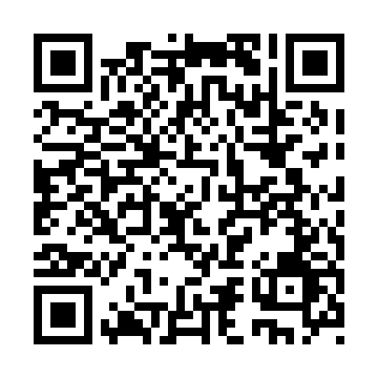

**Prayer times for Pleasant Camp, British Columbia, Canada**

**Sun 1 Sep 2024 - Mon 30 Sep 2024**

**High Latitude Method: Angle Based Rule**

**Prayer Calculation Method: Islamic Society of North America**

**Asar Calculation Method: Hanafi**

|  |  |  |  |  |  |  |  |
| --- | --- | --- | --- | --- | --- | --- | --- |
| **Date** | **Day** | **Fajr** | **Sunrise** | **Dhuhr** | **Asr** | **Maghrib** | **Isha** |
| 1 | Sun | 4:50 | 7:04 | 2:06 | 6:44 | 9:06 | 11:19 |
| 2 | Mon | 4:54 | 7:06 | 2:05 | 6:42 | 9:03 | 11:14 |
| 3 | Tue | 4:58 | 7:09 | 2:05 | 6:39 | 9:00 | 11:10 |
| 4 | Wed | 5:01 | 7:11 | 2:05 | 6:37 | 8:57 | 11:06 |
| 5 | Thu | 5:05 | 7:13 | 2:04 | 6:35 | 8:54 | 11:02 |
| 6 | Fri | 5:08 | 7:15 | 2:04 | 6:33 | 8:51 | 10:58 |
| 7 | Sat | 5:11 | 7:18 | 2:04 | 6:30 | 8:48 | 10:54 |
| 8 | Sun | 5:15 | 7:20 | 2:03 | 6:28 | 8:45 | 10:50 |
| 9 | Mon | 5:18 | 7:22 | 2:03 | 6:25 | 8:42 | 10:46 |
| 10 | Tue | 5:21 | 7:25 | 2:03 | 6:23 | 8:39 | 10:42 |
| 11 | Wed | 5:24 | 7:27 | 2:02 | 6:21 | 8:36 | 10:38 |
| 12 | Thu | 5:27 | 7:29 | 2:02 | 6:18 | 8:33 | 10:35 |
| 13 | Fri | 5:30 | 7:31 | 2:01 | 6:16 | 8:30 | 10:31 |
| 14 | Sat | 5:33 | 7:34 | 2:01 | 6:13 | 8:27 | 10:27 |
| 15 | Sun | 5:36 | 7:36 | 2:01 | 6:11 | 8:24 | 10:24 |
| 16 | Mon | 5:39 | 7:38 | 2:00 | 6:09 | 8:21 | 10:20 |
| 17 | Tue | 5:42 | 7:41 | 2:00 | 6:06 | 8:18 | 10:16 |
| 18 | Wed | 5:45 | 7:43 | 2:00 | 6:04 | 8:15 | 10:13 |
| 19 | Thu | 5:48 | 7:45 | 1:59 | 6:01 | 8:12 | 10:09 |
| 20 | Fri | 5:50 | 7:47 | 1:59 | 5:59 | 8:09 | 10:06 |
| 21 | Sat | 5:53 | 7:50 | 1:59 | 5:56 | 8:06 | 10:02 |
| 22 | Sun | 5:56 | 7:52 | 1:58 | 5:54 | 8:03 | 9:59 |
| 23 | Mon | 5:59 | 7:54 | 1:58 | 5:51 | 8:00 | 9:56 |
| 24 | Tue | 6:01 | 7:57 | 1:58 | 5:48 | 7:57 | 9:52 |
| 25 | Wed | 6:04 | 7:59 | 1:57 | 5:46 | 7:54 | 9:49 |
| 26 | Thu | 6:07 | 8:01 | 1:57 | 5:43 | 7:51 | 9:46 |
| 27 | Fri | 6:09 | 8:04 | 1:57 | 5:41 | 7:48 | 9:42 |
| 28 | Sat | 6:12 | 8:06 | 1:56 | 5:38 | 7:45 | 9:39 |
| 29 | Sun | 6:14 | 8:08 | 1:56 | 5:36 | 7:42 | 9:36 |
| 30 | Mon | 6:17 | 8:10 | 1:56 | 5:33 | 7:39 | 9:33 |

**Prayer times provided by https://www.salahtimes.com**