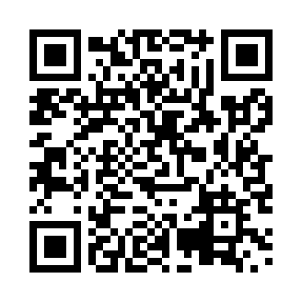
Prayer times for Tower Lake, British Columbia, Canada
Mon 1 Jul 2024 - Wed 31 Jul 2024
High Latitude Method: Angle Based Rule
Prayer Calculation Method: Islamic Society of North America
Asar Calculation Method: Hanafi

Date | Day | Fajr | Sunrise | Dhuhr | Asr | Maghrib | Isha
1 | Mon | 2:44 | 4:21 | 1:06 | 6:53 | 9:51 | 11:29
2 | Tue | 2:44 | 4:22 | 1:07 | 6:53 | 9:50 | 11:28
3 | Wed | 2:45 | 4:23 | 1:07 | 6:53 | 9:50 | 11:28
4 | Thu | 2:45 | 4:24 | 1:07 | 6:53 | 9:49 | 11:28
5 | Fri | 2:46 | 4:25 | 1:07 | 6:53 | 9:48 | 11:28
6 | Sat | 2:47 | 4:26 | 1:07 | 6:52 | 9:48 | 11:27
7 | Sun | 2:47 | 4:28 | 1:07 | 6:52 | 9:47 | 11:27
8 | Mon | 2:48 | 4:29 | 1:08 | 6:52 | 9:46 | 11:26
9 | Tue | 2:49 | 4:30 | 1:08 | 6:51 | 9:45 | 11:26
10 | Wed | 2:49 | 4:31 | 1:08 | 6:51 | 9:44 | 11:26
11 | Thu | 2:50 | 4:33 | 1:08 | 6:50 | 9:43 | 11:25
12 | Fri | 2:51 | 4:34 | 1:08 | 6:50 | 9:41 | 11:25
13 | Sat | 2:52 | 4:35 | 1:08 | 6:49 | 9:40 | 11:24
14 | Sun | 2:52 | 4:37 | 1:08 | 6:48 | 9:39 | 11:23
15 | Mon | 2:53 | 4:38 | 1:08 | 6:48 | 9:38 | 11:23
16 | Tue | 2:54 | 4:40 | 1:08 | 6:47 | 9:36 | 11:22
17 | Wed | 2:55 | 4:41 | 1:09 | 6:46 | 9:35 | 11:22
18 | Thu | 2:56 | 4:43 | 1:09 | 6:46 | 9:33 | 11:21
19 | Fri | 2:56 | 4:45 | 1:09 | 6:45 | 9:32 | 11:20
20 | Sat | 2:57 | 4:46 | 1:09 | 6:44 | 9:30 | 11:19
21 | Sun | 2:58 | 4:48 | 1:09 | 6:43 | 9:29 | 11:19
22 | Mon | 2:59 | 4:50 | 1:09 | 6:42 | 9:27 | 11:18
23 | Tue | 3:00 | 4:51 | 1:09 | 6:41 | 9:25 | 11:17
24 | Wed | 3:01 | 4:53 | 1:09 | 6:41 | 9:24 | 11:16
25 | Thu | 3:02 | 4:55 | 1:09 | 6:40 | 9:22 | 11:15
26 | Fri | 3:03 | 4:57 | 1:09 | 6:39 | 9:20 | 11:14
27 | Sat | 3:03 | 4:58 | 1:09 | 6:37 | 9:18 | 11:13
28 | Sun | 3:04 | 5:00 | 1:09 | 6:36 | 9:16 | 11:12
29 | Mon | 3:05 | 5:02 | 1:09 | 6:35 | 9:14 | 11:11
30 | Tue | 3:06 | 5:04 | 1:09 | 6:34 | 9:12 | 11:10
31 | Wed | 3:07 | 5:06 | 1:09 | 6:33 | 9:10 | 11:09
Prayer times provided by https://www.salahtimes.com

