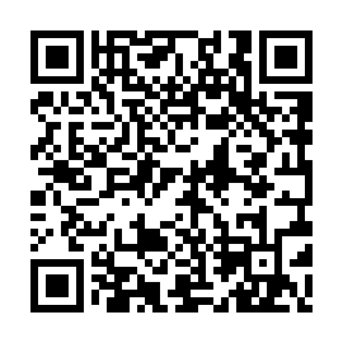
Prayer times for Deschambault Lake, Saskatchewan, Canada
Mon 1 Jul 2024 - Wed 31 Jul 2024
High Latitude Method: Angle Based Rule
Prayer Calculation Method: Islamic Society of North America
Asar Calculation Method: Hanafi

Date | Day | Fajr | Sunrise | Dhuhr | Asr | Maghrib | Isha
1 | Mon | 2:39 | 4:20 | 12:58 | 6:42 | 9:34 | 11:16
2 | Tue | 2:39 | 4:21 | 12:58 | 6:42 | 9:34 | 11:16
3 | Wed | 2:40 | 4:22 | 12:58 | 6:41 | 9:33 | 11:15
4 | Thu | 2:40 | 4:23 | 12:58 | 6:41 | 9:33 | 11:15
5 | Fri | 2:41 | 4:24 | 12:58 | 6:41 | 9:32 | 11:15
6 | Sat | 2:42 | 4:25 | 12:58 | 6:41 | 9:31 | 11:15
7 | Sun | 2:42 | 4:26 | 12:59 | 6:40 | 9:30 | 11:14
8 | Mon | 2:43 | 4:27 | 12:59 | 6:40 | 9:30 | 11:14
9 | Tue | 2:44 | 4:29 | 12:59 | 6:40 | 9:29 | 11:14
10 | Wed | 2:44 | 4:30 | 12:59 | 6:39 | 9:28 | 11:13
11 | Thu | 2:45 | 4:31 | 12:59 | 6:39 | 9:27 | 11:13
12 | Fri | 2:46 | 4:32 | 12:59 | 6:38 | 9:26 | 11:12
13 | Sat | 2:46 | 4:34 | 12:59 | 6:38 | 9:24 | 11:12
14 | Sun | 2:47 | 4:35 | 12:59 | 6:37 | 9:23 | 11:11
15 | Mon | 2:48 | 4:36 | 1:00 | 6:37 | 9:22 | 11:11
16 | Tue | 2:49 | 4:38 | 1:00 | 6:36 | 9:21 | 11:10
17 | Wed | 2:49 | 4:39 | 1:00 | 6:35 | 9:19 | 11:09
18 | Thu | 2:50 | 4:41 | 1:00 | 6:35 | 9:18 | 11:09
19 | Fri | 2:51 | 4:42 | 1:00 | 6:34 | 9:17 | 11:08
20 | Sat | 2:52 | 4:44 | 1:00 | 6:33 | 9:15 | 11:07
21 | Sun | 2:53 | 4:45 | 1:00 | 6:32 | 9:14 | 11:07
22 | Mon | 2:53 | 4:47 | 1:00 | 6:31 | 9:12 | 11:06
23 | Tue | 2:54 | 4:49 | 1:00 | 6:31 | 9:11 | 11:05
24 | Wed | 2:55 | 4:50 | 1:00 | 6:30 | 9:09 | 11:04
25 | Thu | 2:56 | 4:52 | 1:00 | 6:29 | 9:07 | 11:03
26 | Fri | 2:57 | 4:54 | 1:00 | 6:28 | 9:06 | 11:03
27 | Sat | 2:57 | 4:55 | 1:00 | 6:27 | 9:04 | 11:02
28 | Sun | 2:58 | 4:57 | 1:00 | 6:26 | 9:02 | 11:01
29 | Mon | 2:59 | 4:59 | 1:00 | 6:25 | 9:00 | 11:00
30 | Tue | 3:00 | 5:01 | 1:00 | 6:24 | 8:58 | 10:59
31 | Wed | 3:01 | 5:02 | 1:00 | 6:22 | 8:56 | 10:58
Prayer times provided by https://www.salahtimes.com

