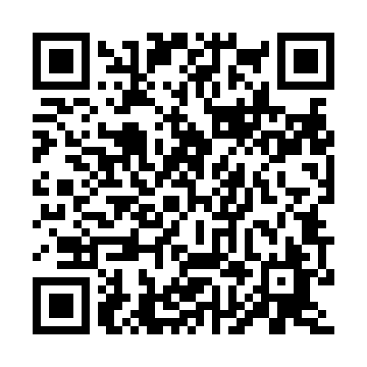
Prayer times for Cranbury Station, New Jersey, USA
Mon 1 Apr 2024 - Tue 30 Apr 2024
High Latitude Method: Angle Based Rule
Prayer Calculation Method: Islamic Society of North America
Asar Calculation Method: Shafi

Date | Day | Fajr | Sunrise | Dhuhr | Asr | Maghrib | Isha
1 | Mon | 5:24 | 6:41 | 1:02 | 4:37 | 7:23 | 8:40
2 | Tue | 5:23 | 6:39 | 1:01 | 4:37 | 7:24 | 8:41
3 | Wed | 5:21 | 6:38 | 1:01 | 4:37 | 7:25 | 8:42
4 | Thu | 5:19 | 6:36 | 1:01 | 4:38 | 7:26 | 8:43
5 | Fri | 5:17 | 6:34 | 1:00 | 4:38 | 7:27 | 8:45
6 | Sat | 5:15 | 6:33 | 1:00 | 4:39 | 7:28 | 8:46
7 | Sun | 5:14 | 6:31 | 1:00 | 4:39 | 7:29 | 8:47
8 | Mon | 5:12 | 6:30 | 1:00 | 4:39 | 7:30 | 8:48
9 | Tue | 5:10 | 6:28 | 12:59 | 4:40 | 7:31 | 8:49
10 | Wed | 5:08 | 6:27 | 12:59 | 4:40 | 7:32 | 8:51
11 | Thu | 5:07 | 6:25 | 12:59 | 4:40 | 7:33 | 8:52
12 | Fri | 5:05 | 6:23 | 12:59 | 4:41 | 7:34 | 8:53
13 | Sat | 5:03 | 6:22 | 12:58 | 4:41 | 7:35 | 8:55
14 | Sun | 5:01 | 6:20 | 12:58 | 4:41 | 7:36 | 8:56
15 | Mon | 4:59 | 6:19 | 12:58 | 4:42 | 7:37 | 8:57
16 | Tue | 4:58 | 6:17 | 12:58 | 4:42 | 7:38 | 8:58
17 | Wed | 4:56 | 6:16 | 12:57 | 4:42 | 7:39 | 9:00
18 | Thu | 4:54 | 6:14 | 12:57 | 4:42 | 7:41 | 9:01
19 | Fri | 4:52 | 6:13 | 12:57 | 4:43 | 7:42 | 9:02
20 | Sat | 4:51 | 6:12 | 12:57 | 4:43 | 7:43 | 9:04
21 | Sun | 4:49 | 6:10 | 12:57 | 4:43 | 7:44 | 9:05
22 | Mon | 4:47 | 6:09 | 12:56 | 4:44 | 7:45 | 9:06
23 | Tue | 4:45 | 6:07 | 12:56 | 4:44 | 7:46 | 9:08
24 | Wed | 4:44 | 6:06 | 12:56 | 4:44 | 7:47 | 9:09
25 | Thu | 4:42 | 6:05 | 12:56 | 4:44 | 7:48 | 9:10
26 | Fri | 4:40 | 6:03 | 12:56 | 4:45 | 7:49 | 9:12
27 | Sat | 4:39 | 6:02 | 12:56 | 4:45 | 7:50 | 9:13
28 | Sun | 4:37 | 6:01 | 12:55 | 4:45 | 7:51 | 9:14
29 | Mon | 4:35 | 5:59 | 12:55 | 4:45 | 7:52 | 9:16
30 | Tue | 4:34 | 5:58 | 12:55 | 4:46 | 7:53 | 9:17
Prayer times provided by https://www.salahtimes.com

