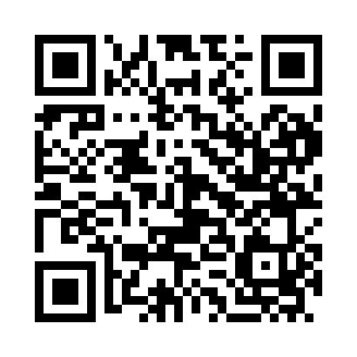
Prayer times for Grombalia, Tunisia
Mon 1 Apr 2024 - Tue 30 Apr 2024
High Latitude Method: Angle Based Rule
Prayer Calculation Method: Tunisian Ministry of Religious Affairs
Asar Calculation Method: Shafi

Date | Day | Fajr | Sunrise | Dhuhr | Asr | Maghrib | Isha
1 | Mon | 4:36 | 6:04 | 12:22 | 3:56 | 6:41 | 8:09
2 | Tue | 4:34 | 6:02 | 12:21 | 3:56 | 6:41 | 8:10
3 | Wed | 4:32 | 6:01 | 12:21 | 3:56 | 6:42 | 8:11
4 | Thu | 4:31 | 5:59 | 12:21 | 3:57 | 6:43 | 8:12
5 | Fri | 4:29 | 5:58 | 12:21 | 3:57 | 6:44 | 8:13
6 | Sat | 4:27 | 5:56 | 12:20 | 3:57 | 6:45 | 8:14
7 | Sun | 4:26 | 5:55 | 12:20 | 3:57 | 6:46 | 8:15
8 | Mon | 4:24 | 5:53 | 12:20 | 3:58 | 6:47 | 8:16
9 | Tue | 4:22 | 5:52 | 12:19 | 3:58 | 6:47 | 8:17
10 | Wed | 4:21 | 5:51 | 12:19 | 3:58 | 6:48 | 8:18
11 | Thu | 4:19 | 5:49 | 12:19 | 3:58 | 6:49 | 8:20
12 | Fri | 4:17 | 5:48 | 12:19 | 3:58 | 6:50 | 8:21
13 | Sat | 4:16 | 5:47 | 12:18 | 3:59 | 6:51 | 8:22
14 | Sun | 4:14 | 5:45 | 12:18 | 3:59 | 6:52 | 8:23
15 | Mon | 4:13 | 5:44 | 12:18 | 3:59 | 6:53 | 8:24
16 | Tue | 4:11 | 5:42 | 12:18 | 3:59 | 6:53 | 8:25
17 | Wed | 4:09 | 5:41 | 12:17 | 3:59 | 6:54 | 8:26
18 | Thu | 4:08 | 5:40 | 12:17 | 3:59 | 6:55 | 8:28
19 | Fri | 4:06 | 5:39 | 12:17 | 4:00 | 6:56 | 8:29
20 | Sat | 4:04 | 5:37 | 12:17 | 4:00 | 6:57 | 8:30
21 | Sun | 4:03 | 5:36 | 12:17 | 4:00 | 6:58 | 8:31
22 | Mon | 4:01 | 5:35 | 12:16 | 4:00 | 6:59 | 8:32
23 | Tue | 4:00 | 5:33 | 12:16 | 4:00 | 7:00 | 8:34
24 | Wed | 3:58 | 5:32 | 12:16 | 4:00 | 7:00 | 8:35
25 | Thu | 3:57 | 5:31 | 12:16 | 4:00 | 7:01 | 8:36
26 | Fri | 3:55 | 5:30 | 12:16 | 4:01 | 7:02 | 8:37
27 | Sat | 3:53 | 5:29 | 12:16 | 4:01 | 7:03 | 8:38
28 | Sun | 3:52 | 5:27 | 12:15 | 4:01 | 7:04 | 8:40
29 | Mon | 3:50 | 5:26 | 12:15 | 4:01 | 7:05 | 8:41
30 | Tue | 3:49 | 5:25 | 12:15 | 4:01 | 7:06 | 8:42
Prayer times provided by https://www.salahtimes.com

