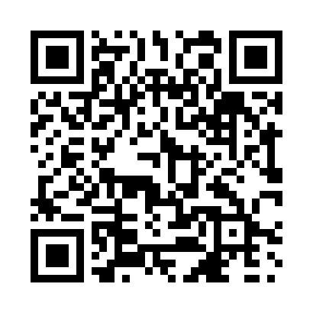
Prayer times for Beauchamp, Quebec, Canada
Mon 1 Apr 2024 - Tue 30 Apr 2024
High Latitude Method: Angle Based Rule
Prayer Calculation Method: Islamic Society of North America
Asar Calculation Method: Hanafi

Date | Day | Fajr | Sunrise | Dhuhr | Asr | Maghrib | Isha
1 | Mon | 4:53 | 6:19 | 12:44 | 5:13 | 7:10 | 8:36
2 | Tue | 4:51 | 6:17 | 12:44 | 5:14 | 7:12 | 8:38
3 | Wed | 4:49 | 6:15 | 12:44 | 5:15 | 7:13 | 8:40
4 | Thu | 4:46 | 6:13 | 12:43 | 5:16 | 7:14 | 8:41
5 | Fri | 4:44 | 6:11 | 12:43 | 5:17 | 7:16 | 8:43
6 | Sat | 4:42 | 6:09 | 12:43 | 5:18 | 7:17 | 8:45
7 | Sun | 4:40 | 6:07 | 12:42 | 5:19 | 7:18 | 8:46
8 | Mon | 4:37 | 6:05 | 12:42 | 5:20 | 7:20 | 8:48
9 | Tue | 4:35 | 6:04 | 12:42 | 5:21 | 7:21 | 8:50
10 | Wed | 4:33 | 6:02 | 12:42 | 5:22 | 7:22 | 8:51
11 | Thu | 4:31 | 6:00 | 12:41 | 5:23 | 7:24 | 8:53
12 | Fri | 4:28 | 5:58 | 12:41 | 5:23 | 7:25 | 8:55
13 | Sat | 4:26 | 5:56 | 12:41 | 5:24 | 7:27 | 8:57
14 | Sun | 4:24 | 5:54 | 12:41 | 5:25 | 7:28 | 8:58
15 | Mon | 4:22 | 5:52 | 12:40 | 5:26 | 7:29 | 9:00
16 | Tue | 4:19 | 5:51 | 12:40 | 5:27 | 7:31 | 9:02
17 | Wed | 4:17 | 5:49 | 12:40 | 5:28 | 7:32 | 9:04
18 | Thu | 4:15 | 5:47 | 12:40 | 5:29 | 7:33 | 9:05
19 | Fri | 4:13 | 5:45 | 12:39 | 5:30 | 7:35 | 9:07
20 | Sat | 4:11 | 5:43 | 12:39 | 5:31 | 7:36 | 9:09
21 | Sun | 4:08 | 5:42 | 12:39 | 5:31 | 7:37 | 9:11
22 | Mon | 4:06 | 5:40 | 12:39 | 5:32 | 7:39 | 9:13
23 | Tue | 4:04 | 5:38 | 12:39 | 5:33 | 7:40 | 9:15
24 | Wed | 4:02 | 5:36 | 12:39 | 5:34 | 7:41 | 9:16
25 | Thu | 3:59 | 5:35 | 12:38 | 5:35 | 7:43 | 9:18
26 | Fri | 3:57 | 5:33 | 12:38 | 5:36 | 7:44 | 9:20
27 | Sat | 3:55 | 5:31 | 12:38 | 5:36 | 7:45 | 9:22
28 | Sun | 3:53 | 5:30 | 12:38 | 5:37 | 7:47 | 9:24
29 | Mon | 3:51 | 5:28 | 12:38 | 5:38 | 7:48 | 9:26
30 | Tue | 3:49 | 5:27 | 12:38 | 5:39 | 7:49 | 9:28
Prayer times provided by https://www.salahtimes.com

