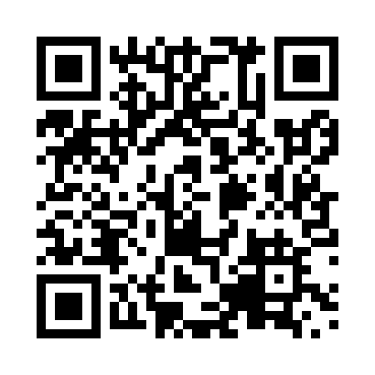

**Prayer times for Nuvulik, Quebec, Canada**

**Sun 1 Sep 2024 - Mon 30 Sep 2024**

**High Latitude Method: Angle Based Rule**

**Prayer Calculation Method: Islamic Society of North America**

**Asar Calculation Method: Hanafi**

|  |  |  |  |  |  |  |  |
| --- | --- | --- | --- | --- | --- | --- | --- |
| **Date** | **Day** | **Fajr** | **Sunrise** | **Dhuhr** | **Asr** | **Maghrib** | **Isha** |
| 1 | Sun | 3:12 | 5:34 | 12:39 | 5:18 | 7:43 | 10:04 |
| 2 | Mon | 3:16 | 5:37 | 12:39 | 5:15 | 7:40 | 9:59 |
| 3 | Tue | 3:20 | 5:39 | 12:39 | 5:13 | 7:37 | 9:54 |
| 4 | Wed | 3:24 | 5:41 | 12:38 | 5:11 | 7:34 | 9:50 |
| 5 | Thu | 3:28 | 5:44 | 12:38 | 5:08 | 7:31 | 9:46 |
| 6 | Fri | 3:32 | 5:46 | 12:38 | 5:06 | 7:28 | 9:41 |
| 7 | Sat | 3:36 | 5:49 | 12:37 | 5:04 | 7:24 | 9:37 |
| 8 | Sun | 3:39 | 5:51 | 12:37 | 5:01 | 7:21 | 9:33 |
| 9 | Mon | 3:43 | 5:54 | 12:37 | 4:59 | 7:18 | 9:28 |
| 10 | Tue | 3:46 | 5:56 | 12:36 | 4:56 | 7:15 | 9:24 |
| 11 | Wed | 3:50 | 5:58 | 12:36 | 4:54 | 7:12 | 9:20 |
| 12 | Thu | 3:53 | 6:01 | 12:36 | 4:51 | 7:09 | 9:16 |
| 13 | Fri | 3:56 | 6:03 | 12:35 | 4:49 | 7:06 | 9:12 |
| 14 | Sat | 3:59 | 6:06 | 12:35 | 4:46 | 7:03 | 9:08 |
| 15 | Sun | 4:03 | 6:08 | 12:34 | 4:44 | 6:59 | 9:04 |
| 16 | Mon | 4:06 | 6:10 | 12:34 | 4:41 | 6:56 | 9:00 |
| 17 | Tue | 4:09 | 6:13 | 12:34 | 4:39 | 6:53 | 8:57 |
| 18 | Wed | 4:12 | 6:15 | 12:33 | 4:36 | 6:50 | 8:53 |
| 19 | Thu | 4:15 | 6:18 | 12:33 | 4:33 | 6:47 | 8:49 |
| 20 | Fri | 4:18 | 6:20 | 12:33 | 4:31 | 6:44 | 8:45 |
| 21 | Sat | 4:21 | 6:23 | 12:32 | 4:28 | 6:41 | 8:42 |
| 22 | Sun | 4:24 | 6:25 | 12:32 | 4:26 | 6:38 | 8:38 |
| 23 | Mon | 4:27 | 6:27 | 12:32 | 4:23 | 6:34 | 8:35 |
| 24 | Tue | 4:30 | 6:30 | 12:31 | 4:20 | 6:31 | 8:31 |
| 25 | Wed | 4:33 | 6:32 | 12:31 | 4:18 | 6:28 | 8:28 |
| 26 | Thu | 4:35 | 6:35 | 12:31 | 4:15 | 6:25 | 8:24 |
| 27 | Fri | 4:38 | 6:37 | 12:30 | 4:12 | 6:22 | 8:21 |
| 28 | Sat | 4:41 | 6:40 | 12:30 | 4:10 | 6:19 | 8:17 |
| 29 | Sun | 4:44 | 6:42 | 12:30 | 4:07 | 6:16 | 8:14 |
| 30 | Mon | 4:46 | 6:44 | 12:29 | 4:04 | 6:13 | 8:10 |

**Prayer times provided by https://www.salahtimes.com**